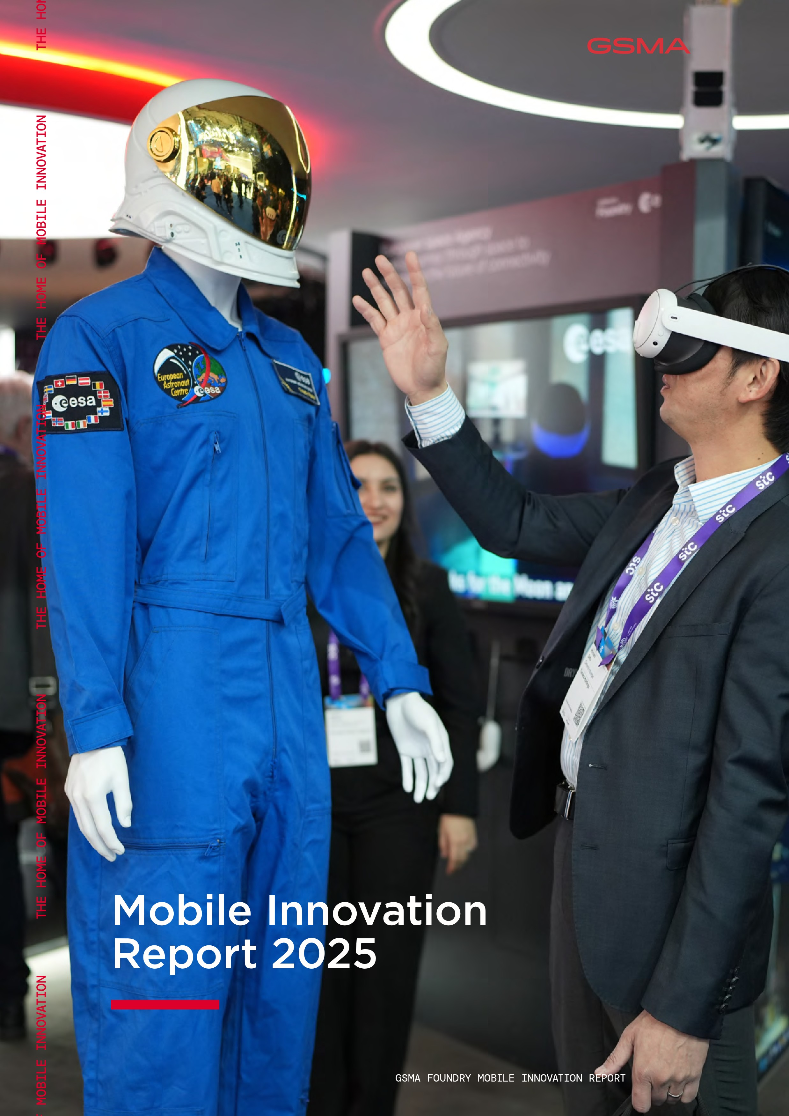

**MOBILE INNOVATION REPORT 2025**

# **About the GSMA**

The GSMA is a global organisation unifying the mobile ecosystem to discover, develop and deliver innovation foundational to positive business environments and societal change. Our vision is to unlock the full power of connectivity so that people, industry, and society thrive.

Representing mobile operators and organisations across the mobile ecosystem and adjacent industries, the GSMA delivers for its members across three broad pillars: Connectivity for Good, Industry Services and Solutions, and Outreach. This activity includes advancing policy, tackling today’s biggest societal challenges, underpinning the technology and interoperability that make mobile work, and providing the world’s largest platform to convene the mobile ecosystem at the MWC and M360 series of events.

We invite you to find out more at gsma.com.

# **About the GSMA Foundry**

The GSMA Foundry is the go-to place for cross-industry collaboration and making positive change happen, supported by leading technology organisations and companies. By bringing together members and key industry players, engaging, and unifying the end-to-end connectivity ecosystem, the GSMA Foundry is solving real-world industry challenges.

Find out more and get involved at https://www.gsma.com/foundry



**E OF MOBILE INNOVATION THE HOME OF MOBILE INNOVATION THE HOME OF MOBILE INNOVATION THE HOME OF MOBILE INNOVATION THE**

**MOBILE INNOVATION REPORT 2025**

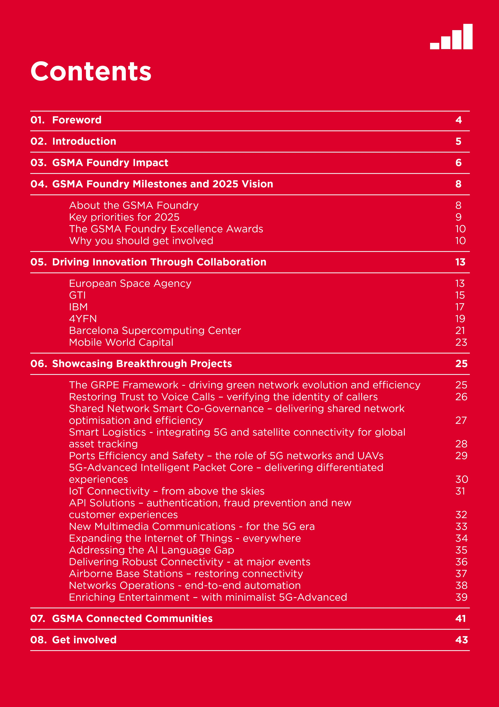

# **01.** FOREWORD

In the mobile industry, as in the broader economy, the pace of change is accelerating. Technological advances, particularly in artificial intelligence (AI), are opening up new avenues for innovation that are creating considerable value for individuals and organisations alike.

At the same time, 5G is becoming increasingly capable and versatile, enabling mobile operators – our members – to play a broader role in the digital transformation of the economy and society at large. To help them do that, the GSMA Foundry is working closely with innovative organisations, both large and small, including some of the most advanced tech players in the world.

Since it launched in 2021, the Foundry and its partners have delivered more than 70 projects, including 18 in 2024. By harnessing the right expertise and making the right contacts, the Foundry has progressed ideas, concepts, prototypes and even solutions to a point where they can begin changing the world.

To fulfil its mission, the Foundry has forged important partnerships, notably with Barcelona Supercomputing Center (BSC), the European

Space Agency (ESA), IBM, GTI, 4YFN and Mobile World Capital. These partnerships are fuelling innovation through a mix of challenges, funding, awards and educational programmes. Moreover, these collaborations are helping the GSMA’s members get to grips with exciting new technologies, such as 5G-Advanced, non-terrestrial networks (NTN), and, of course, AI.

Indeed, the Foundry is key to the GSMA’s efforts to realise the full potential of 5G and catalyse new growth for the mobile industry. That growth will continue through this decade. By 2030, mobile operators worldwide will be generating US$1.25 trillion per annum in aggregate, up from US$1.11 trillion in 2023, according to the GSMA’s Mobile Economy report. The increase in revenues will be driven by rising adoption of 5G, which is set to count for more than half of global mobile connections by 2029.

For both the mobile industry and its billions of customers, we need to ensure this growth is sustainable in the long-term. As this innovation report shows, the GSMA Foundry and its partners are addressing the most pressing societal challenges of our era, from climate change and energy conservation to economic growth and inequalities. Indeed, the Foundry’s achievements in 2024 dovetail well with the GSMA’s vision - to unlock the full power of connectivity so that people, industry and society thrive.

For example, the Foundry is collaborating with Mobile World Capital to launch global ESG awards underlining the industry’s commitment to sustainability. In a similar vein, at COP29, the GSMA Foundry showcased the positive impact of the industry’s energy efficiency initiatives both on its own networks and enabling other industries to reduce their carbon emissions.

Given the Foundry’s track record to date, I am confident it will have an even greater impact in 2025 and beyond.



Mats Granryd - Director General, GSMA

|  |
| --- |
| **02.** INTRODUCTION |

As the boundaries between industries become increasingly blurred and information travels faster and faster, exciting new ideas can emerge anywhere at any time. To help the mobile ecosystem turn the most promising ideas and concepts into major new products and services, the GSMA Foundry matches entrepreneurs with investors and big companies. By efficiently identifying promising innovations from around the world, the Foundry is saving mobile operators and their partners both time and money.

As well as supporting new concepts and commercial trials, the Foundry helps proven solutions achieve scale at a regional or global level. To that end, we harness the expertise and experience of business leaders through an open exchange of learnings and insights. As a result, stakeholders can quickly refine and develop ideas that benefit the telecoms sector and its customers.

A key GSMA goal is to accelerate AI adoption for start-ups, system integrators and mobile operators across the globe. In 2024, many of the Foundry’s activities involved AI in one way or another. For example, our partnership with Barcelona Supercomputing Center, which is addressing the AI language gap, has helped telecoms group VEON to build large language models (LLMs) tailored to the needs of specific markets. As a direct result of this engagement, KazLLM developed from a two billion parameter model to a 70 billion parameter model within a few short months, thereby enabling AI services for Kazakhstan to become more capable and accurate.

Meanwhile, our partnership with IBM, which is democratising access to AI tools and resources, has already led to six mobile operators harnessing IBM’s watsonx.ai platform. SLTMobitel, for example, has used the platform to deploy AI to support call agents, while KPN is employing AI to better create and manage its enterprise documents. Working with vendors and mobile operators, the GSMA Foundry has also built an AI Use Case Library, which is continually updated with cutting-edge applications of AI in the telecom industry. At the same time, the Foundry has launched challenges with GTI to fuel the development of solutions that combine 5G Advanced and AI.

The breadth and depth of our work on AI highlights the agility of the Foundry and its ability to stay on top of new technologies. Indeed, I am very proud of the impact the Foundry has had in just three years. It has successfully built upon and enhanced the GSMA’s impressive global network of experts in business, technology, policy and regulation. That network is the product of decades spent convening the global ecosystem through everything from small workshops to major events attracting more than 100,000 people.

In this report, you will find many more inspiring examples of how the Foundry is nurturing mobile innovation and creating value both within the mobile ecosystem and beyond. If you’d like to be part of that, please get in touch and help us find the next great mobile innovations.



Richard Cockle - Head of GSMA Foundry

# **03.** GSMA FOUNDRY IMPACT

**70**

**2021**

+

since



**Projects**

**delivered**

**Foundry Projects**

**18**

**2024**

+

in

**Projects**

**completed**

**Projects Completed**



**Innovation Spotlight** Every month, we showcase a Foundry partner who is driving innovation in the

**Interview Series** mobile industry. Join us for a conversation about the real-world challenges they’re solving and the impact their technology is making.

Watch on demand or join us for future events.

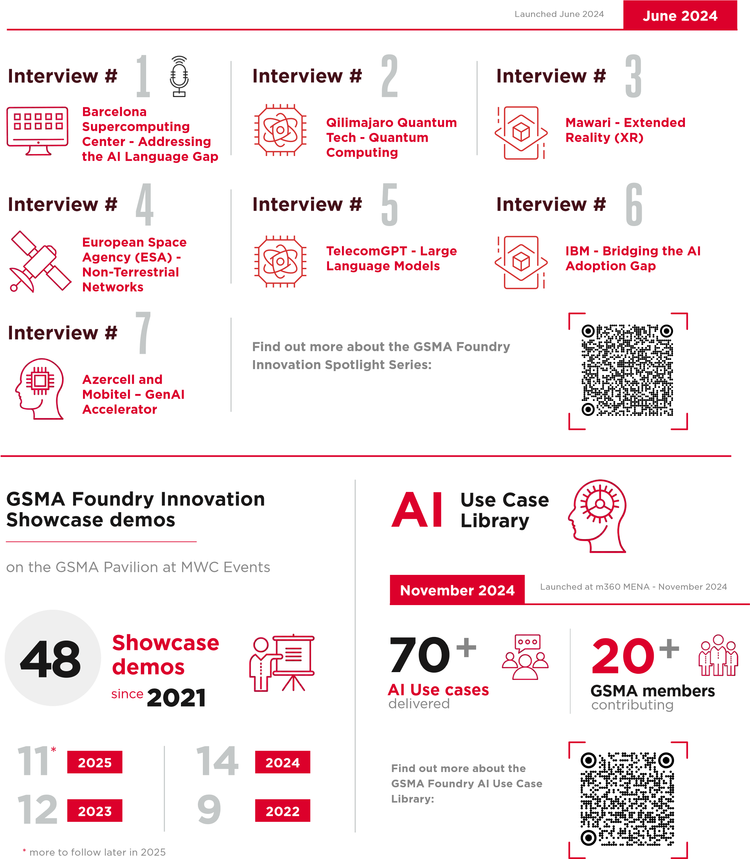

# **04.** GSMA FOUNDRY MILESTONES AND 2025 VISION

## About the GSMA Foundry

The GSMA Foundry is the Home of Mobile Innovation. Since it was established in 2021, the Foundry has become the go-to hub for cross-industry collaboration and business development, where GSMA members rapidly develop real-world solutions, nurture new ideas and scale proven solutions globally to shape the digital future.

By facilitating open innovation, the Foundry is helping mobile operators to maximise the impact of their investments and avoid duplicating efforts. To that end, the GSMA Foundry is building strategic partnerships and collaboration, while matching smart ideas and entrepreneurs with appropriate investors and other sources of funding.

With a global mandate, the Foundry is nurturing everything from brand-new concepts and products in commercial trials right through to proven solutions that require scaling to a regional or global level. It has already empowered scores of innovators to swiftly develop their solutions, conduct commercial trials and expand proven solutions that will shape the digital future.

In 2024 the GSMA Foundry focused on the following areas:

1. 5G: The GSMA Foundry is at the forefront of 5G innovation, enabling members to develop and scale 5G solutions globally. For example, in 2024, Bewhere Smart Logistics designed inte grated 5G and satellite solutions for global asset tracking to ensure the safe and timely delivery of freight across supply chains.
2. Non-Terrestrial Networks (NTN): The Foundry fosters collaboration to develop NTN solutions, such as satellite and drone connectivity. For example, through the challenges launched with the European Space Agency (see next section), the Foundry has secured GSMA members millions of euros to fund satellite-related activities.
3. Artificial Intelligence (AI): Members can leverage the Foundry to advance AI and its integration into the mobile industry. For example, in 2024, the Foundry built an AI Use Case Library, a collaborative effort with vendors and mobile network operators to showcase cutting-edge applications of AI in the telecom industry. Over 70 real-world AI use cases from across the globe were launched at m360 MENA 2024, with contributions from Ericsson, Huawei, IBM, Nokia, Qualcomm and ZTE Corporation showcasing how AI is enhancing everything from customer service to network planning.
4. Efficiency: The Foundry supports initiatives to enhance both the energy efficiency and the overall efficiency of mobile networks and operations. For example, in 2024, China Telecom and China Unicom extended their innovative partnership to co-govern their shared infrastructure to encompass their 4G networks and their 5G networks. China Telecom and China Unicom established and optimised the world’s first, largest and fastest shared 5G Standalone network which minimised the total cost of ownership of the shared network. As of October 2024, the single network had deployed 1.37 million shared 5G base stations and reconstructed over two million shared 4G base stations.
5. Monetisation: The Foundry helps members explore new monetisation strategies and business models. For example, in 2024, China Mobile, Huawei and AIS collaborated to employ an intelligent packet core to enhance the user experience of 5G networks and open up new monetisation opportunities.

## Key priorities for 2025

1. Strategic partnerships: The Foundry is working closely with industry leaders to drive multi-pronged industry initiatives and collaborations, creating new opportunities for growth and innovation. The Foundry’s partnership with the European Space Agency (ESA), for example, has developed an NTN community, launching challenges and funding opportunities, broadening access to the ESA’s 5G/6G NTN Labs and rolling out education programmes. The Foundry is also partnering with Barcelona Supercomputing Center (BSC) to support the development of large language models (LLMs) for underrepresented languages. This initiative aims to bridge the AI language gap by developing

generative AI systems that cater to local

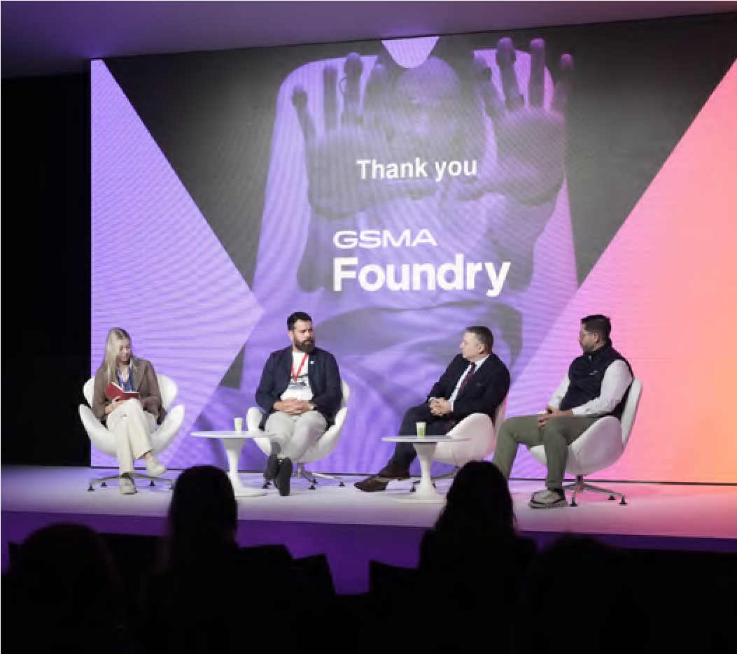

languages (see next section for more information).

1. Launching innovation funding and challenges: The Foundry plays a pivotal role in matching funding with innovative projects. At MWC Barcelona 2024, it coordinated the award of approximately €18 million from ESA to support innovative projects and initiatives in the mobile industry. The Foundry and BSC will also be launching the AINA Challenge in 2025, which will have a €1 million prize fund for the best LLM use cases in Catalan.
2. Expanding the telco labs network: To enable innovators to access scalable lab resources, the Foundry is building a global platform for “labs-as-a-service”. Through the Foundry’s strategic relationships, it has access to a range of industry-leading lab facilities, which members can use to foster collaboration and innovation. The Foundry is also creating a global directory of telco labs that drive innovation in telecommunications. The directory will provide a platform through which labs can showcase their work worldwide and open new opportunities to collaborate with a wide range of industry players.

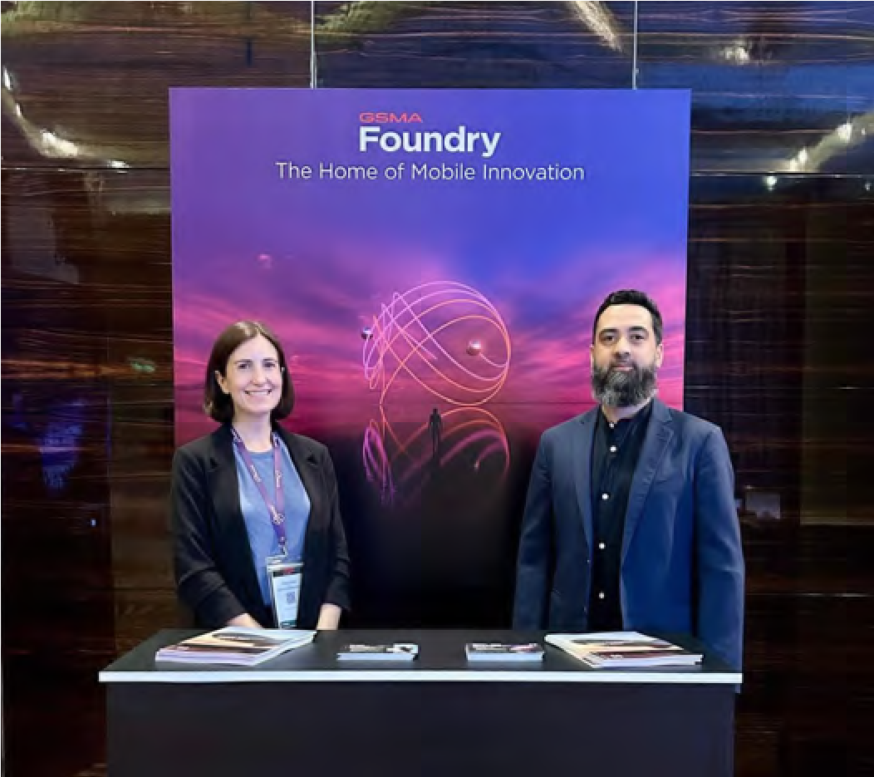

4YFN Innovation Panel, MWC Barcelona 2024

Nicola Gordon and Faisal Zia, showcasing GSMA Foundry at m360 Eurasia 2024

|  |
| --- |
| **GSMA Foundry Excellence Award Winners**  Winners  **5G Monetisation Award**  AIS, China Mobile, e&, Globe, Huawei, STC, Sunrise and Zain KSA  **Non-Terrestrial Networks (NTN) Award**  Sateliot - Expanding the Internet of Things  Everywhere  **Artificial Intelligence Award**  VEON with Beeline Kazakhstan and Qazcode Kaz LLM – Addressing the AI Language Gap **Network Efficiency and Optimisation Award**  China Mobile and ZTE - End-to-End Automation of Networks Operations  **Outstanding Industry Vertical Award**  CloudRAN.ai - Delivering Robust Connectivity at Major Events  Winners      **Non-core Revenues Award**  World Mobile - Connecting the Unconnected  **5G Monetisation Award**  China Mobile and ZTE - 5G Automated Farming  **Digital Transformation Award**  Amazon Web Services (AWS) Liberty Global, and Unmanned Life- 5G Connected Drones Promise Better Security **Network Efficiency Award**  China Telecom and China Unicom - 5G Co-Construction and Sharing  **Outstanding Industry Collaborator** Huawei |

## The GSMA Foundry Excellence Awards

Presented at MWC Barcelona, the GSMA Foundry Excellence Awards recognise the most innovative and significant projects and initiatives in the GSMA Foundry. In 2025, winners included VEON, and partners Beeline Kazakhstan and Qazcode, for their work on developing AI models for low-resource languages addressing the AI language gap and Huawei, alongside partners AIS, China Mobile, e&, Globe, STC, Sunrise and Zain KSA, for a new intelligent packet core to help operators monetise 5G networks. ZTE and China Mobile were honoured for the end-to-end automation of network operations, and Sateliot for developing a low-cost solution for connecting IoT devices to satellites. CloudRAN.ai won the Outstanding Industry Vertical Use Case award for developing a solution that can provide reliable coverage to fast moving devices and vehicles in sports arenas.

Further details of these projects and other Foundry projects are provided later in this report.

## Why you should get involved

The GSMA Foundry helps with strategy, accelerates go-to-market, and unlocks new opportunities. After joining the GSMA Foundry, members will be participating in a dynamic innovation ecosystem where they can collaborate seamlessly with operators, partners and innovators to drive the telecoms industry forward. Foundry members win global recognition by participating in events, an annual awards programme, high-profile digital communications and community discussions. Through the Foundry, you will have the opportunity to drive rapid innovation, revolutionise industries,

and leave a lasting mark on the mobile industry.

To get involved, please contact foundry@gsma.com.

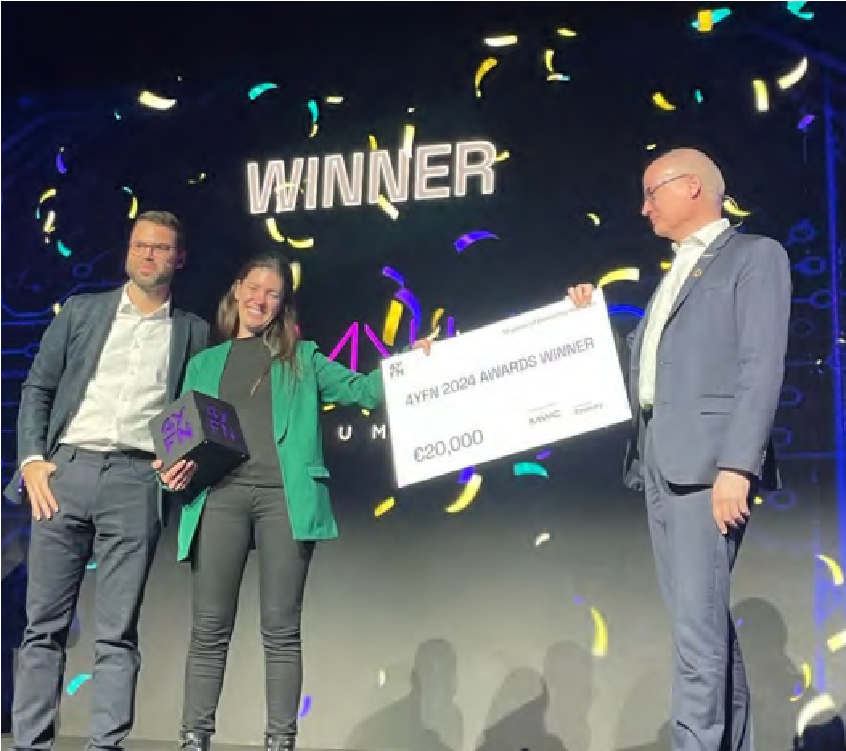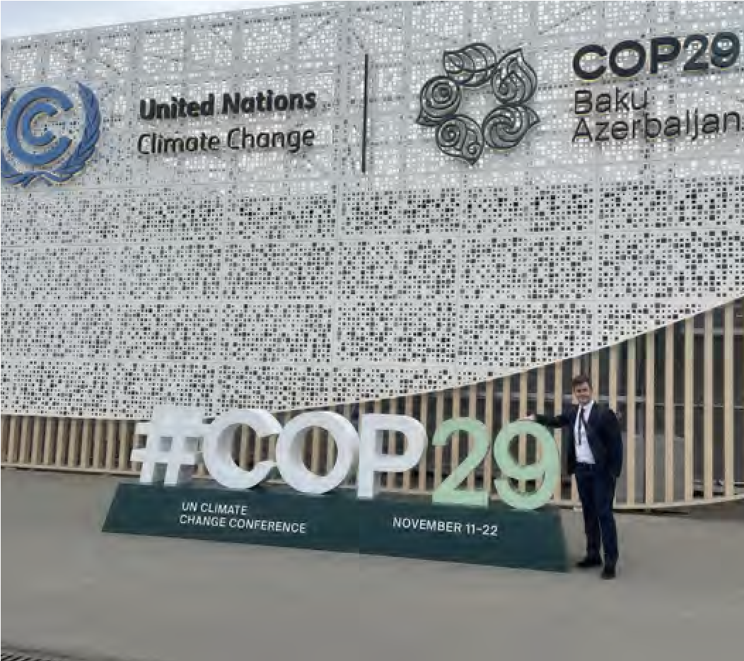

Alex Sinclair, CTO, GSMA presents the 4YFN 2024 winner,

R

ichard Cockle, Head of GSMA Foundry, participating at

Qilimanjaro, with a €20,000 cheque from the GSMA Foundry. COP29, Baku, Azerbaijan, November 2024

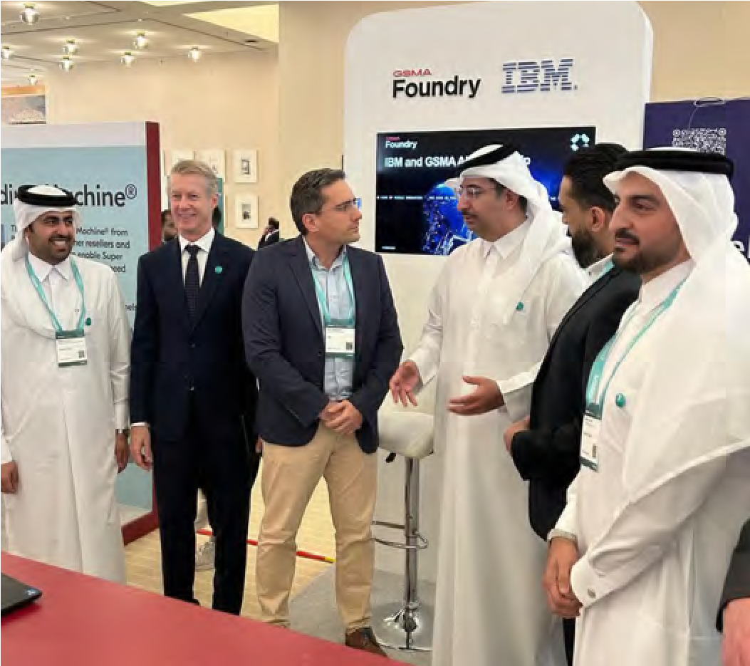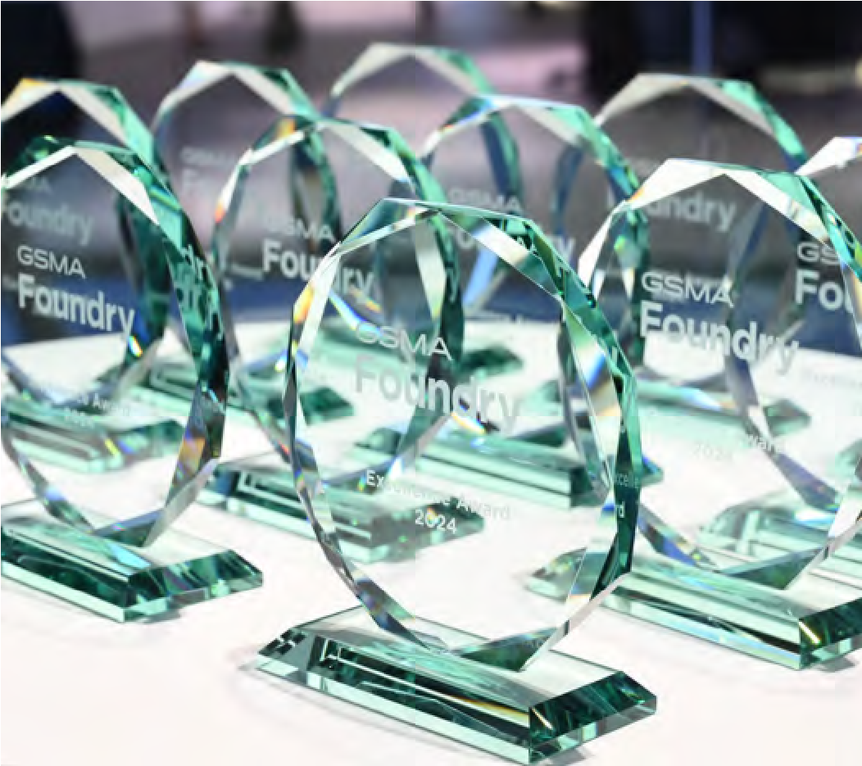

Mats Granryd, Director General, GSMA with Sheikh Ali Bin

G

SMA Foundry Excellence Awards 2024

Jabor Al-Thani, CEO, Ooredoo, Qatar at m360 MENA 2024



Driving Innovation

Through Collaboration

**IVING INNOVATION DRIVING INNOVATION DRIVING INNOVATION DRIVING INNOVATION DRIVING INNOVATION DRIVING INNOVATION**

**MOBILE INNOVATION REPORT 2025**

# **05.** DRIVING INNOVATION THROUGH COLLABORATION – GSMA FOUNDRY

## PARTNERSHIPS

### European Space Agency

At MWC Barcelona in February 2024, the GSMA Foundry and the European Space Agency (ESA) announced multiple initiatives to help the mobile and satellite industries collaborate on developing innovative satellite and terrestrial networks technologies and services, while building new revenue streams.

To that end, the GSMA Foundry and ESA jointly launched two challenges. The 5G Mobility Makerspace challenge attracted 14 applications with more than €12.2 million in total funding requested, while the NTN Open Gateway challenge attracted 11 applications with more than €6.3 million in total funding requested.

The Foundry and ESA have also established a non-terrestrial networks (NTN) community, with close to 50 members, which plans to release a white paper at MWC Barcelona 2025. At the same time, the partnership is enabling Foundry participants to collaborate at ESA’s 5G/6G Hub in Harwell, UK and 5G/6G Telecom Lab in Noordwijk in the Netherlands, while ESA has made its NTN test network available to Foundry participants to enable the real-world testing of their innovations.

The GSMA’s first NTN summit, which was held during MWC Barcelona 2024, was oversubscribed threefold, underlining the interest in this area. The GSMA has since held NTN summits at subsequent MWCs, while launching NTN Roundtables at M360 Seoul.

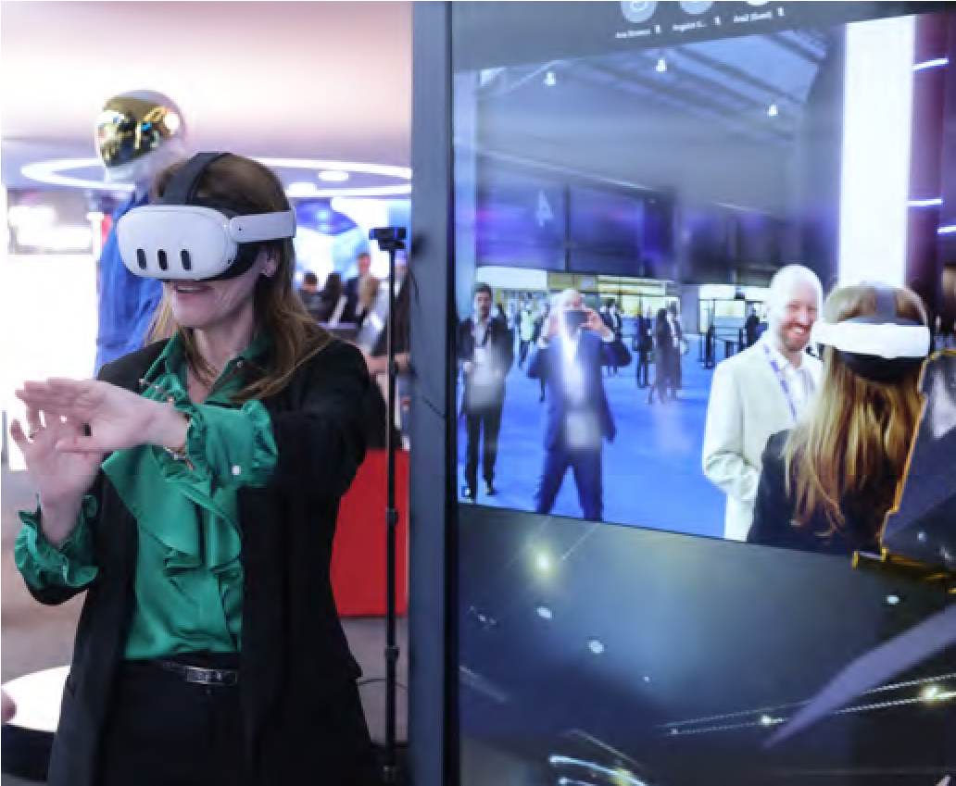

ESA showcase NTN technologies on the GSMA Pavilion at MWC

Barcelona 2024

ESA is proud to partner with the “

GSMA on a variety of impactful initiatives in our commitment to advance connectivity solutions, through the integration of satellite and terrestrial networks. One of ESA’s aims is to connect everyone, everywhere and at any time, and this powerful collaboration with GSMA is a significant step in advancing the mobile and satellite communications industries.

**Antonio Franchi -** ESA’s Head of the 5G/6G

Non-Terrestrial Network (NTN) Programme Office.

**MOBILE INNOVATION REPORT 2025**

### The 5G Mobility Makerspace Challenge



**5**

**G**

€

**12m€+ 14**

total funding Applications requested

#### NTN Community Members established 48+

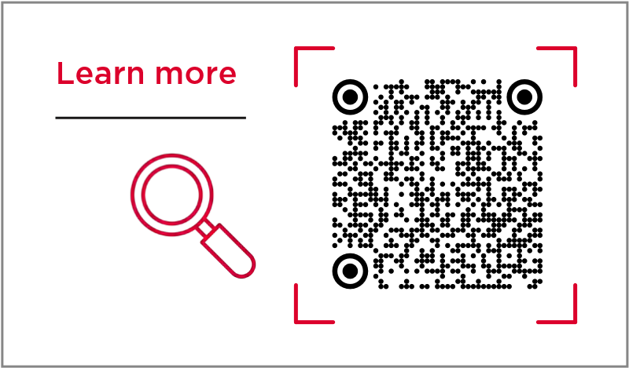

14/44

**NTN Open Gateway challenge**

**6.3**total funding **m€+ 11**Applications requested



**ESA** has committed to

**18m€** GSMA industry challenges.

#### GTI

At MWC Shanghai in June 2024, the GSMA Foundry and GTI, an international platform for industry cooperation, announced they are joining forces to support innovation in the telecoms industry. The partnership is focused on developing converged solutions using 5G Advanced (5G-A) and AI.

In September, during the 40th GTI summit in Hong Kong, GTI and GSMA Foundry launched their first batch of “challenges” aimed at solving industry problems and fostering innovation through the integration of 5G-A and AI technologies:

1. **New Calling x AI Challenge:** Focuses on using AI to advance New Calling (IMS Video, Data Channel) services and develop impactful use cases.
2. **Wireless Network Intelligence:** Focuses on AI-enabled solutions for wireless network intelligence testing and evaluation.

Applications for these challenges opened in October and November, respectively, with resources available at GTI-GSMA Open Labs. The winners, which will be

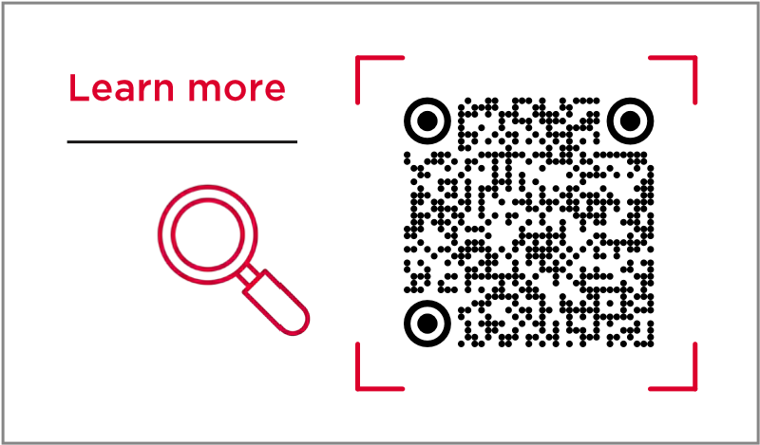

announced at MWC Shanghai 2025, will engage in further collaboration with GTI and GSMA Foundry. This initiative is part of the broader GTI 5G-A×AI Development Program, which aims to drive integrated innovation across technology, business and commerce. Globally, more than 20 mobile operators and partners are already involved in this effort to advance the fusion of 5G-A and AI.

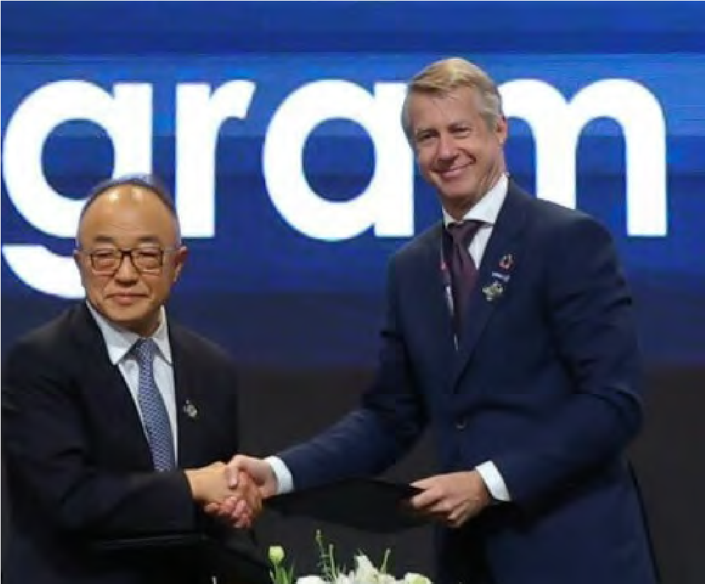

GTI and GSMA Foundry announce partnership at MWC

Shanghai 2024

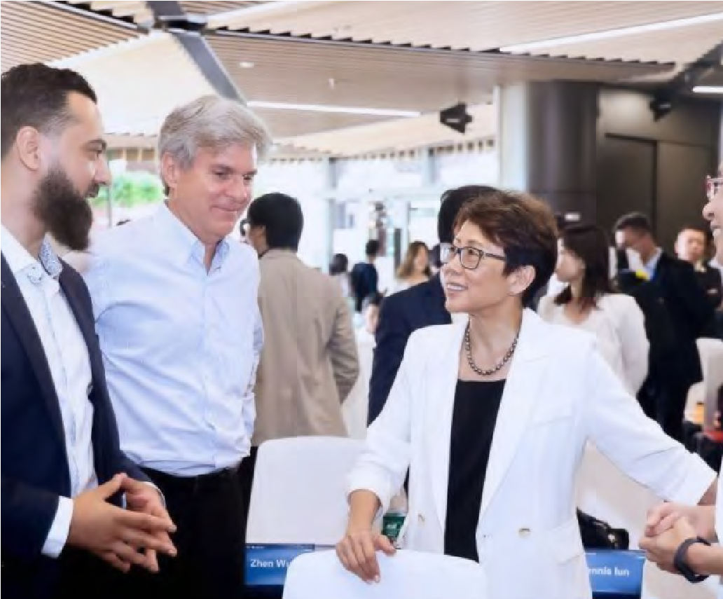

GSMA and GTI teams at the GTI Summit, September 2024



**MOBILE INNOVATION REPORT 2025**

#### IBM

In January 2024, the GSMA Foundry and IBM joined forces to offer GSMA members the opportunity to register for the Gen AI Accelerator Pack, an exclusive programme to help telecom operators unlock the full potential of generative AI.

Designed to accelerate adoption of Gen AI, drive productivity gains, and boost revenue growth, the initiative has

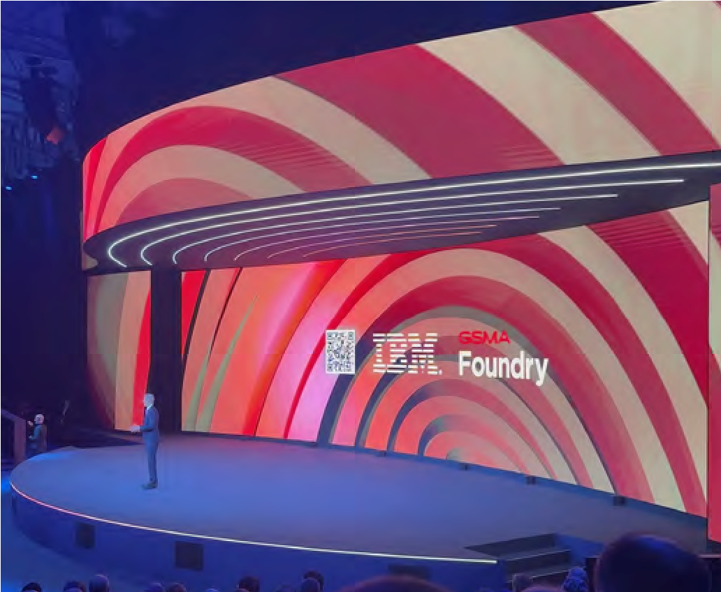

attracted 48 registrations and six active participants (Azercell, Globe, KPN, Ooredoo, STC and SLTMobitel).

IBM also participated in Foundry showcases at MWC Barcelona, Shanghai, Las Vegas, and m360 MENA.

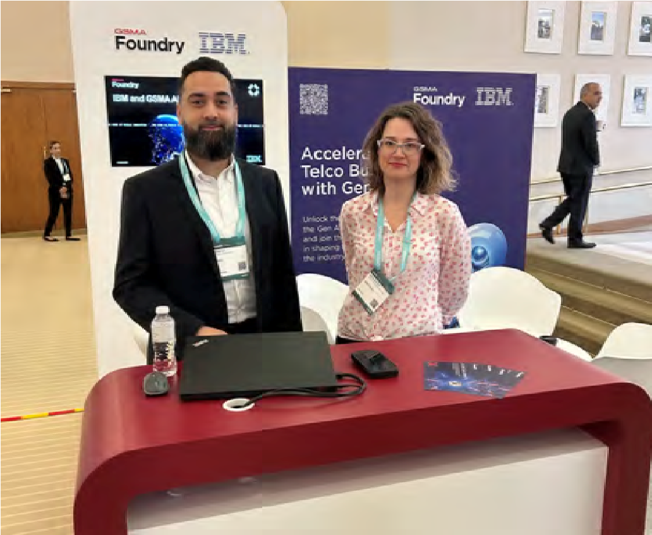

GSMA Director General, Mats Granryd, announces the partnership between IBM and GSMA Foundry in his opening keynote at MWC Barcelona 2024

Faisal Zia and Ioanna Nikolaou, showcasing GSMA Foundry AI initiatives alongside IBM at m360 MENA 2024

|  |
| --- |
| We must thank GSMA and IBM for this great initiative which enable us to utilise IBM’s watsonx.ai platform, an enterprise-grade generative AI solution as a form of exclusive credits to trial generative AI technology, enabling us to demonstrate AI’s value within our organisation. Also, this enables us to access IBM’s subject matter experts whenever we got an issue during our development.  Our development was primarily focus on call centre optimisation where The Aisle solution assisted with IBM models enables to reduce call handling times and enhances agent productivity. As our solution is acting as a gateway for cloud-based model providers, like IBM watsonx models, it enables us to extend the solution to many vertical use cases which are in the pipeline. We always encourage collaborative innovations with partners like IBM to stay abreast of the evolving technology landscape and industry standards without reinventing the wheel as our solution is poised for sustainable growth with a focus on scalability, adaptability and environmental responsibility.    **Anil Pradeep Kumara -** GM/R&D, The Embryo Innovation Center, SLTMOBITEL. |

“

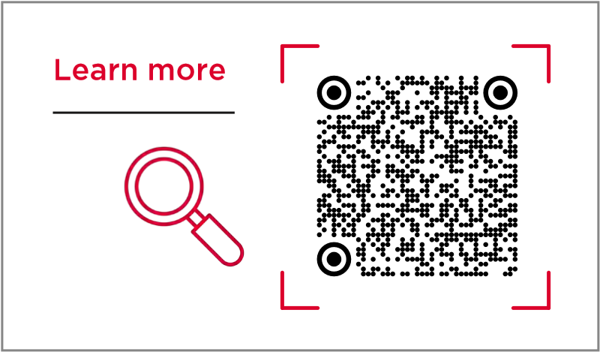

### Gen AI Accelerator Pack



Adoption rates

**48** registrations**6** Active participants Azercell, Globe, KPN,

Ooredoo, STC and SLTMobitel.

#### 4YFN

4YFN, which supports startups through connections, exposure, and investment opportunities, and the GSMA Foundry are working together to drive innovation.

By collaborating with the 4YFN ecosystem, the Foundry provides startups with access to valuable resources, mentorship, and funding opportunities. For the second consecutive year, the GSMA Foundry has sponsored the 4YFN Awards at MWC Barcelona, offering a €20,000 cash prize to the winner. These awards represent the pinnacle of recognition for digital startups, ensuring international exposure and a platform for growth.

As the 4YFN and Foundry partnership grows, it is fuelling a shared mission to empower startups and champion innovation.

The GSMA Foundry has been an “

invaluable and amazing partner for Qilimanjaro since our journey at 4YFN, which we are very proud of. They’ve provided us with numerous opportunities from streaming live podcasts with us to crafting a case study on Qilimanjaro, significantly enhancing our visibility and presence within the tech ecosystem. Through their support, we’ve been able to connect with key players, gain critical exposure, and establish a stronger foothold in the industry. This partnership has only just begun, and we’re excited about the continued growth and opportunities that lie ahead with GSMA Foundry by our side.

**Marta P Estarellas -** CEO, Qilimanjao.

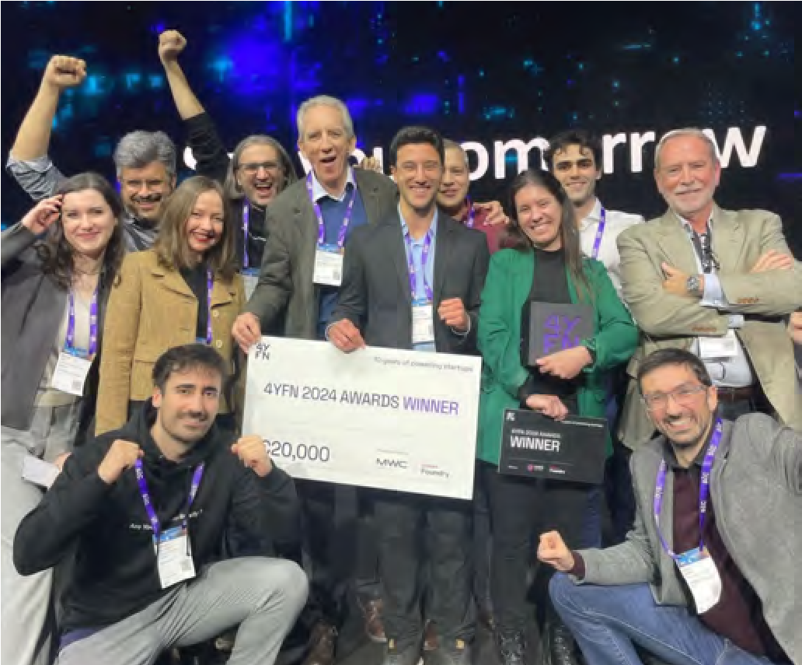

2024 award winners, Qilimanjaro celebrate the win with a

€20,000 cheque from the GSMA Foundry

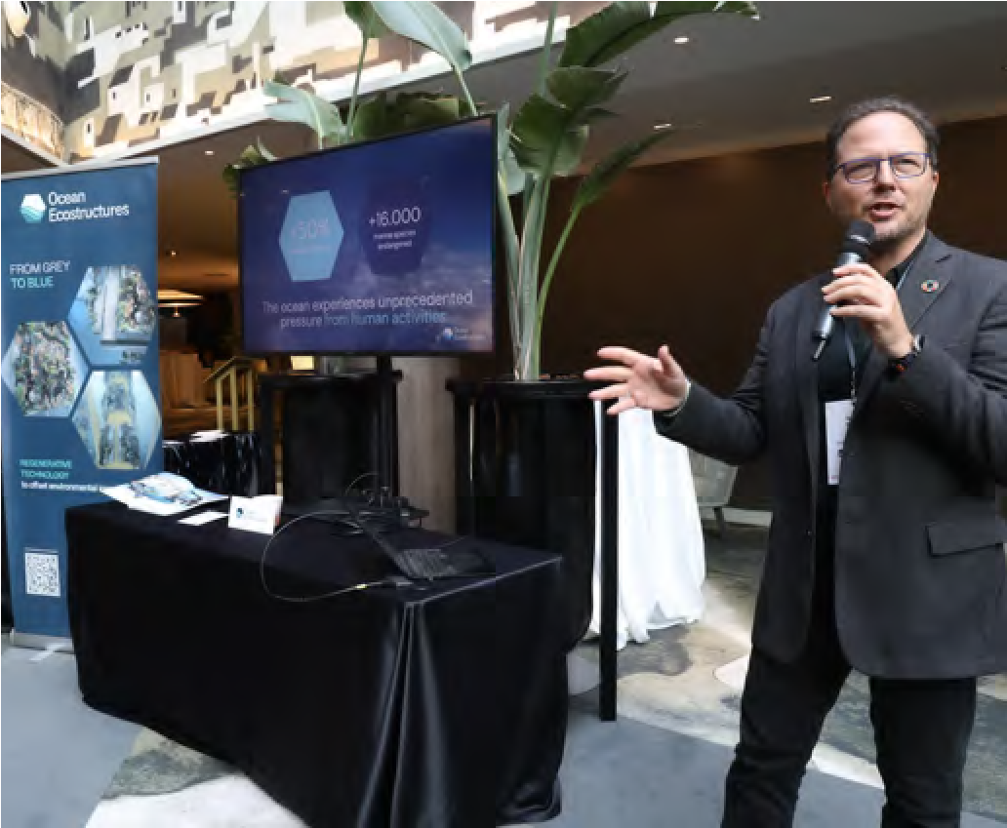

Ignasi Ferrer, CEO and Co-Founder of Ocean Ecostructures presents to the GSMA Strategy Group

|  |  |  |
| --- | --- | --- |
| GSMA Foundry has been instrumental in Bitsensing’s journey. Through their mentorship programmes, we’ve gained access to industry veterans who provided critical guidance on scaling our business globally. Additionally, their network of investors opened up funding opportunities that have supported our growth.  **Jean Lee -** **Bitsensing,** 2024 4YFN Awards finalist. |  | We have been intensively in contact with GSMA Foundry, and their added value has been tremendous. They know the telco ecosystem so well, and they can make the most powerful connections you can ever imagine.  **Joris Castermans -** Founder and CEO, Whispp, 2024 4YFN Awards finalist.  . |

# “ “

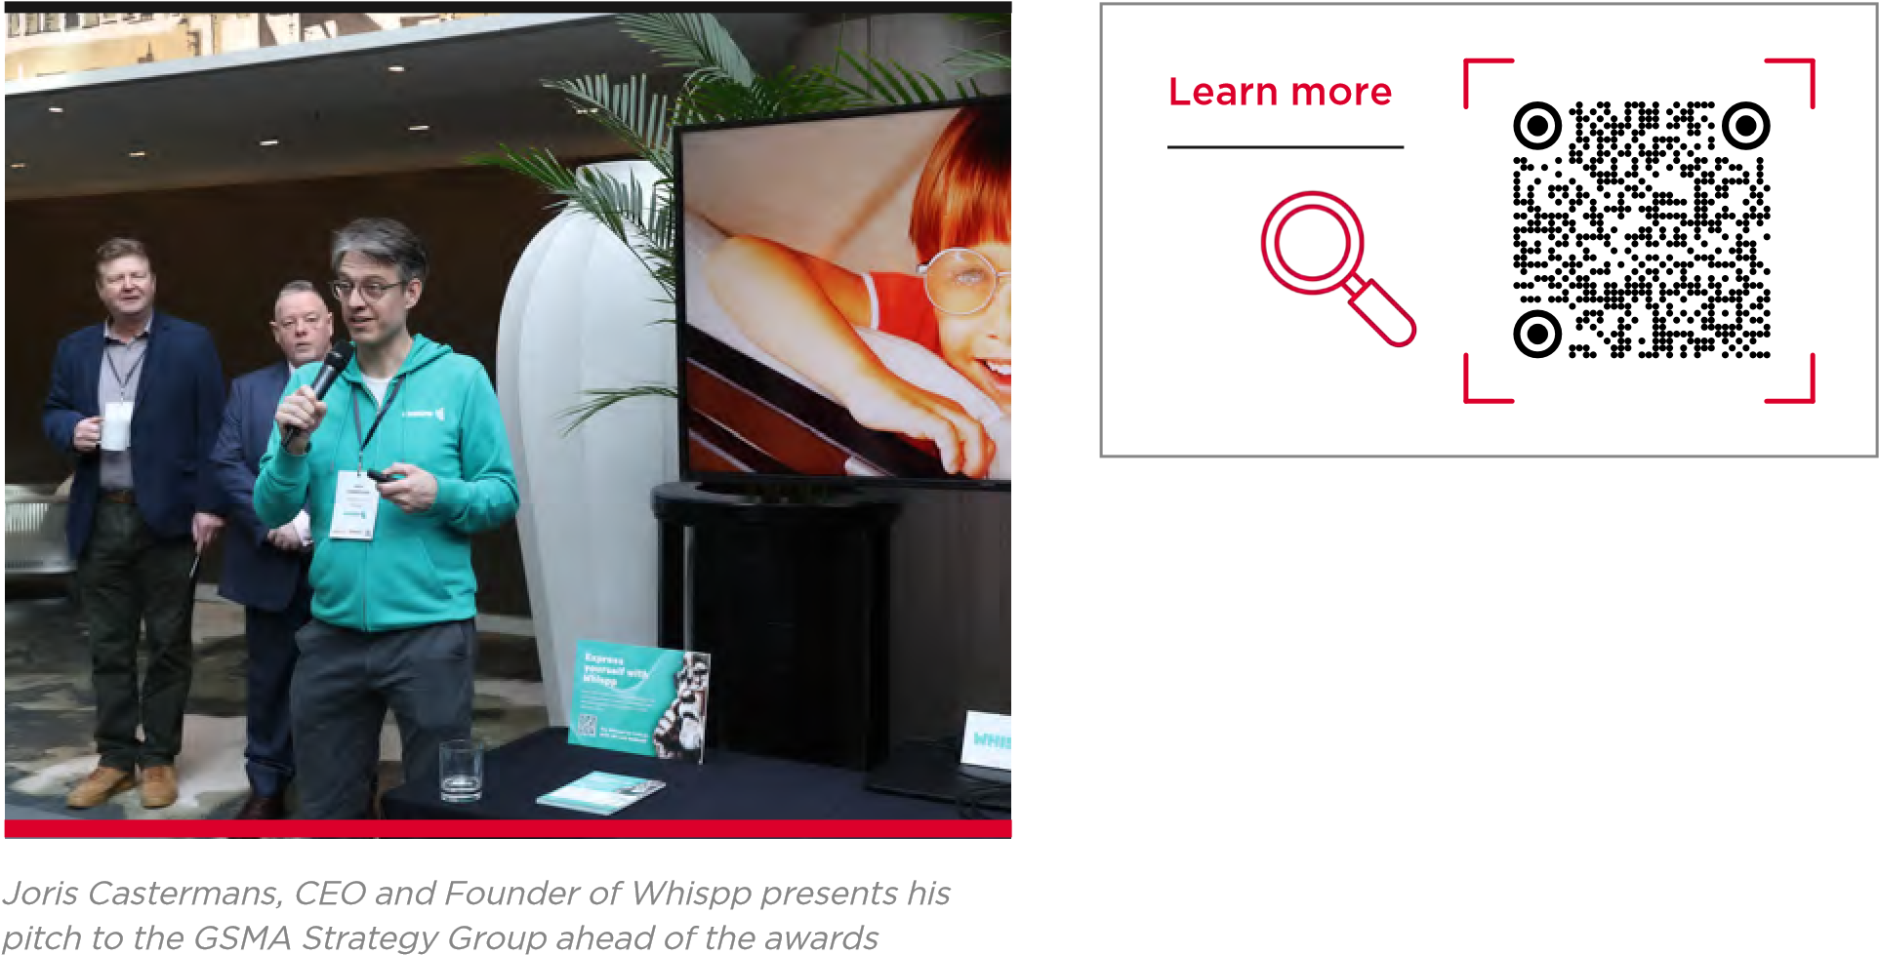

|  |
| --- |
| The Artificial Intelligence is the next game changer in the history of technology, and it is in our hands to design and develop it in a way that promotes inclusion for all. Enabling low-resource languages to be a part of the world of AI empowers hundreds of millions of people around the globe by addressing the current shortcomings of the AI landscape. We are delighted to be the first operator group to partner with Barcelona Supercomputing Center and the GSMA to explore opportunities to raise to this challenge.  **Kaan Terzioglu -** Group CEO of VEON. |

## Barcelona Supercomputing Center “

The GSMA Foundry is working with Barcelona Supercomputing Center (BSC), one of Europe’s leading supercomputing centres and part of the EuroHPC network, to help develop large language models (LLMs) to support AI services tailored to the needs of the telecoms sector and markets that are underserved by existing models.

|  |
| --- |
| Beeline Kazakhstan is the leading operator in AI technologies in the markets where VEON operates. Having previously developed AI-based solutions in Kazakh language, Beeline Kazakhstan and Qazcode are well aware of the challenges and opportunities that come with Kazakhstan’s transformation into the age of AI. We are extremely excited to partner with Barcelona Supercomputing Center and the GSMA, bringing international experience to our journey of developing new use cases for Kazakh-language AI applications  **Evgeny Nastradin -** CEO of Beeline Kazakhstan. |

After first developing the Catalan LLM–AINA, BSC has now developed ALIA for wider Spanish languages and plans to cover 35 EU languages through 2025. BSC will also host one of seven “AI factories” being launched by the European Commission to leverage the supercomputing capacity of the EuroHPC Joint Undertaking to develop trustworthy cutting-edge generative AI models. Kazakhstan and Qazcode to develop mechanisms “

In 2024, the Foundry and BSC partnered with mobile operator group VEON and its subsidiary Beeline

and documentation on language models and AI systems for under-resourced languages, including the local languages of the countries where VEON operates. Out of nearly 7,000 languages spoken around the globe, only seven are considered very high-resource languages in the digital world: English, Spanish, French, Mandarin, Arabic, German and Japanese. The lack of resources in other languages results in an AI language gap and a sub-optimal user experience in AI applications, deepening the bias in AI models and exacerbating the digital divide in AI technologies.

By working with the Foundry and BSC, VEON accelerated its initial three-to-five year timeline to build a LLM and developed the 70 billion parameter Kazakh LLM in just seven months.

|  |
| --- |
| The development of artificial intelligence also generates gaps between languages. It is important to close them. For this reason, we are making our knowledge and resources available. The work through the Aina Alliance keeps growing and has allowed us to sign a strategic agreement with the GSMA. This is one more step for making our open-source AI expertise accessible to the international community. BSC has published a wide-range number of datasets and open-source models through the Aina project, leading the path into the open-source AI resources availability  **Mateo Valero Cortes -** Director of the BSC-CNS. |

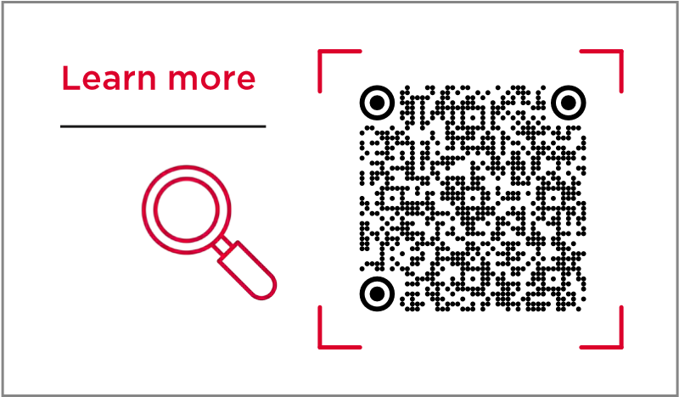



MOU signing at m360 Eurasia 2024 between Barcelona

Supercomputer, Beeline Kazakstan, Veon and GSMA

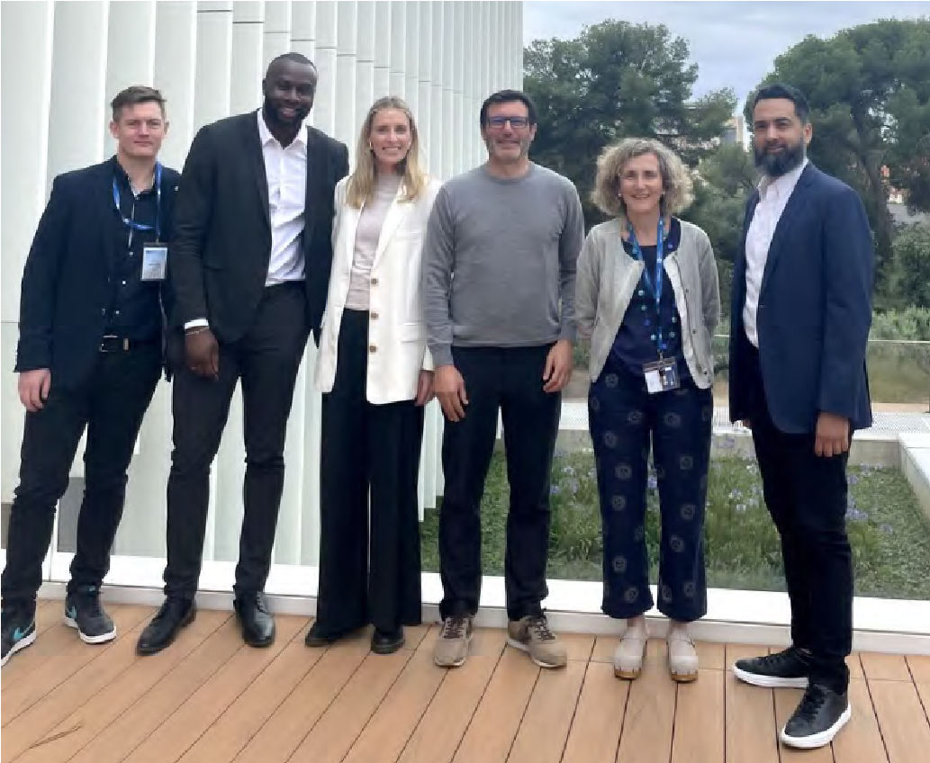

The GSMA Foundry and Barcelona Supercomputing Center

teams at BSC headquarters

“

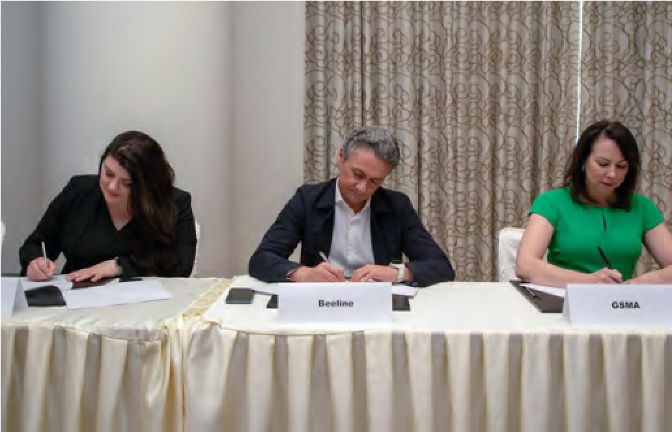

## Mobile World Capital

The GSMA Foundry is partnering with Mobile World Capital Barcelona on the Mobile World Capital Awards in collaboration with B Lab Spain, an initiative that champions technological innovation for a sustainable future.

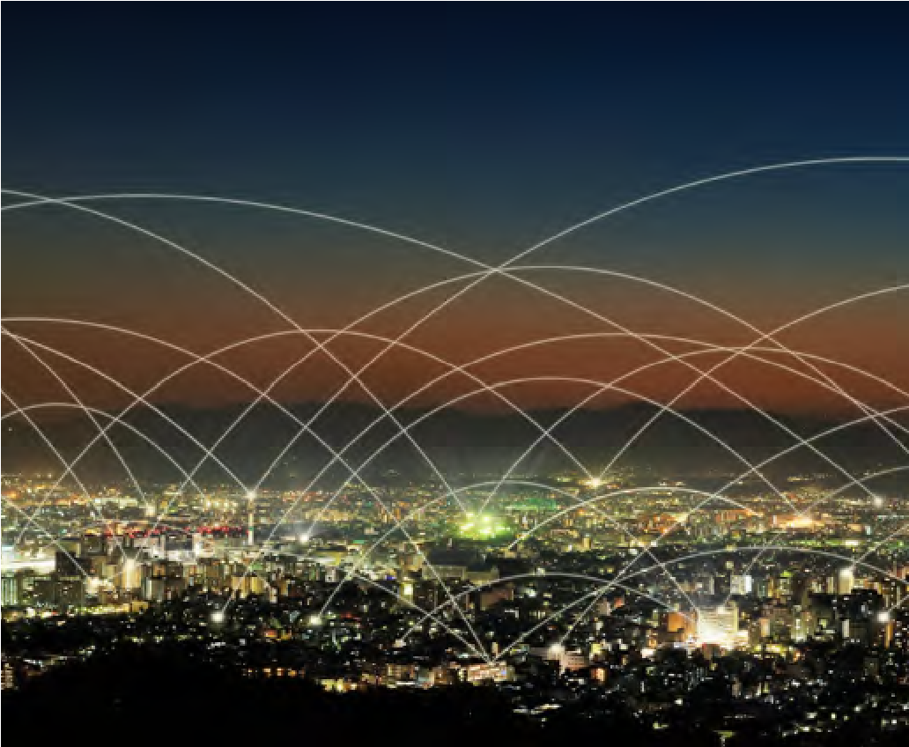

The international awards recognise and reward innovative projects supporting a responsible digital transition and contributing to the achievement of the United Nations’ Sustainable Development Goals. The partners share a mission to drive impactful solutions that tackle issues such as climate change, digital inclusion, and inequality.

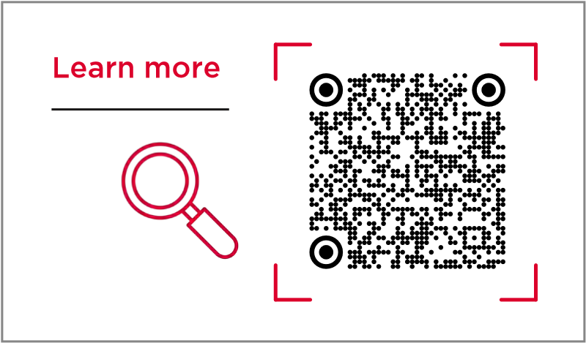For the GSMA Foundry, this partnership represents an opportunity to amplify the power of mobile solutions to create a positive, lasting impact. Technology, when harnessed responsibly, is a powerful enabler of equity and resilience, paving the way for a sustainable digital future. Together, with Mobile World Capital Barcelona, the Foundry is aiming to catalyse change, fostering a world where innovation drives progress for all.

The submissions deadline is in March 2025, with the

Awards Gala taking place in Barcelona in June 2025.



Showcasing

Breakthrough

Projects of 2024

**HROUGH PROJECTS BREAKTHROUGH PROJECTS BREAKTHROUGH PROJECTS BREAKTHROUGH PROJECTS BREAKTHROUGH PROJECTS BREAKTHRO**

**MOBILE INNOVATION REPORT 2025**

## 06. SHOWCASING BREAKTHROUGH PROJECTS OF 2024

**The GRPE Framework - driving green network evolution**

### and efficiency

Network Efficiency, Reliability, Sustainability

Supported by Huawei and the Foundry, China Mobile, Hong Kong Telecom, STC and Telkom Openserve have defined a holistic approach and model, called the GRPE (Green Realisation, Planning, Execution) framework, to help guide operators’ green initiatives and network evolution. The GSMA Foundry was invited to showcase the framework, which encompasses realisation, planning and execution, and its implementations at COP29.

China Mobile is using 5G-Advanced, open APIs, and AI-enabled network planning to harness clean energy, while Hong Kong Telecom is using the framework and open APIs to model and

integrate different data sources to support network site modernisation and new applications, including uncrewed drones for building inspections and emergency medical services. In Saudi Arabia, STC is using AI-based network planning and engineering to support multi-dimensional network insight, service traffic identification and service cut-over orchestration. Meanwhile, Telkom Openserve is using an AI-based energy management system to address energy shortages for its fixed network in South Africa. The system determines the best possible balance of diesel, battery and grid energy based on network data, weather and loadshedding data.



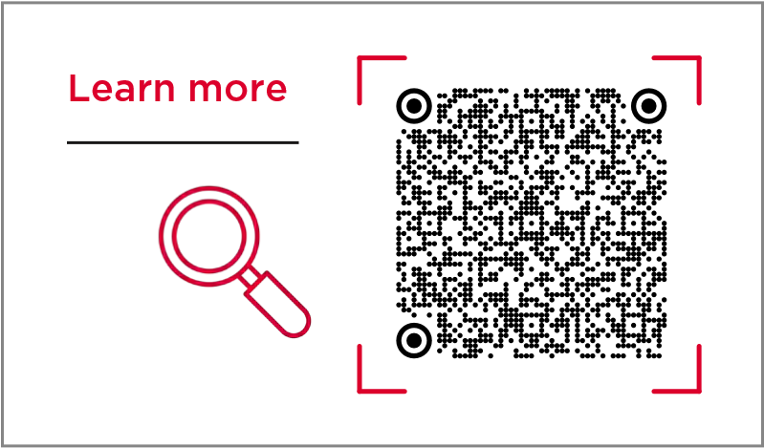

Partners: Huawei, China Mobile, Hong Kong Telecom, STC and Telkom Openserve

### Restoring Trust to Voice Calls – verifying the identity of callers

Customer Experience

In developed markets, many phone calls now come from fraudsters and spammers. To rebuild trust in voice calls and encourage greater phone usage, WIT Software has developed a solution to check if callers are who they say they are. Companies can use the solution to show their logo or info on the recipient’s phone screen.

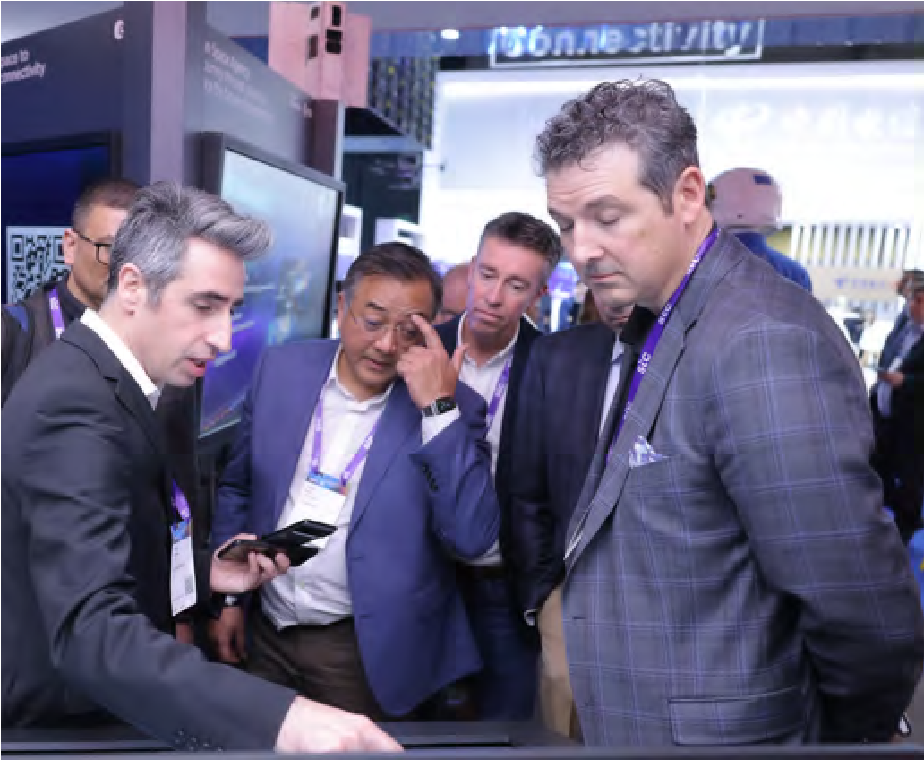

WIT Software believes its technology, which is being tested by more than a dozen companies, will boost demand for phone services. With the help of the Foundry, WIT Software plans to use GSMA protocols for 5G New Calling and the IMS-data channel as more phones become compatible.

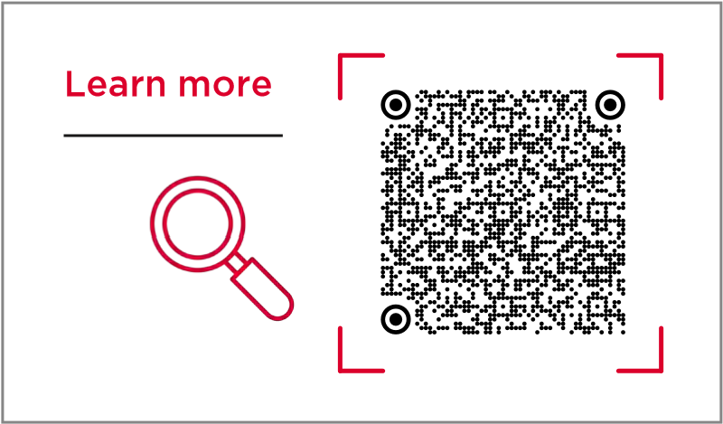

Partners: WIT Software

**Shared Network Smart Co-Governance – delivering shared network**

### optimisation and efficiency

Digital Twin, Network Efficiency

China Telecom and China Unicom have successfully deployed effective technologies and practices for multi-party construction, sharing and lifecycle management of 4G/5G networks. This involved defining a unified set of network coding and key configurations, frequency policies, and network evaluation indicators for use as the yardsticks for joint maintenance and optimisation, leveraging blockchain technology to ensure the storage and consistency of essential key shared parameters, confirmation of work order priorities bilaterally, and exchange of essential parameters based on smart contracts; and the application of digital twins technology to facilitate joint network optimisation.

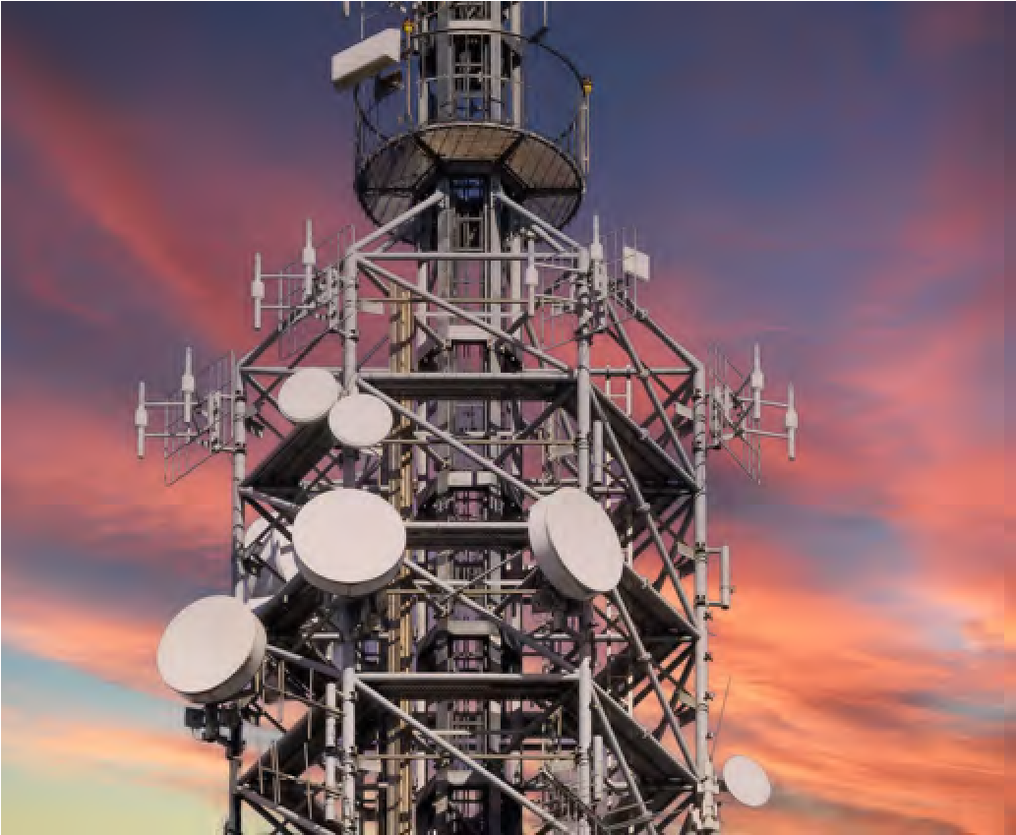

This has enabled them to develop efficient mechanisms for alignment of network configuration and operation, and big data support for bi-lateral joint optimisation of their shared network, which is the world’s first, largest and fastest shared 5G Standalone network.

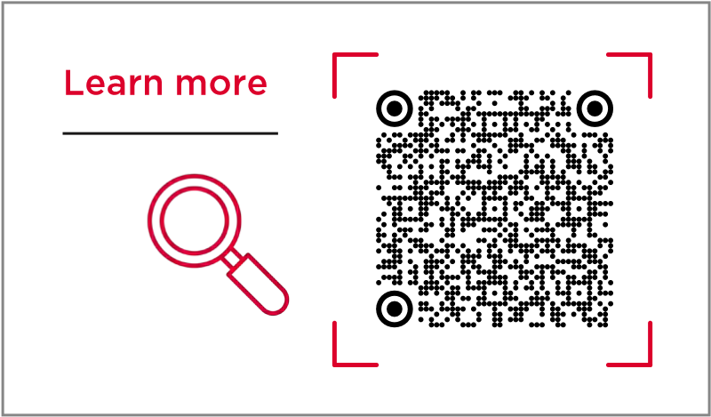

Partners: China Telecom, China Unicom

|  |
| --- |
| **Smart Logistics - integrating 5G and satellite connectivity for global** |

### asset tracking

Non-Terrestrial Networks, Smart Mobility

The integration of 5G and satellite technologies is set to revolutionise asset tracking, offering unprecedented global coverage, reliability and cost-effectiveness. In this Foundry project, Bewhere is exploring smart logistics management and how advanced tracking solutions are transforming supply chain operations.

Smart logistics management is crucial for ensuring the safe and timely delivery of freight across supply chains. It coordinates the complex processes of transportation, warehousing, inventory management and information flow to optimise efficiency and minimise risks. Effective logistics reduce costs, improve customer satisfaction and maintain the integrity of goods during transit. By carefully planning routes, managing resources and leveraging technology, logistics managers can overcome challenges, such as weather disruptions, traffic congestion and ensure regulatory compliance. Ultimately, robust logistics management is the backbone of successful freight operations, enabling businesses to meet delivery commitments, maintain product quality and gain a competitive edge in the global marketplace.

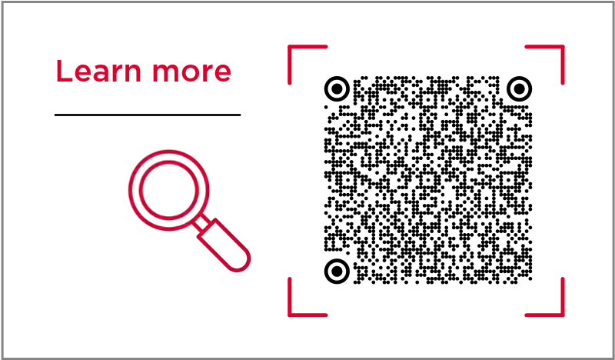

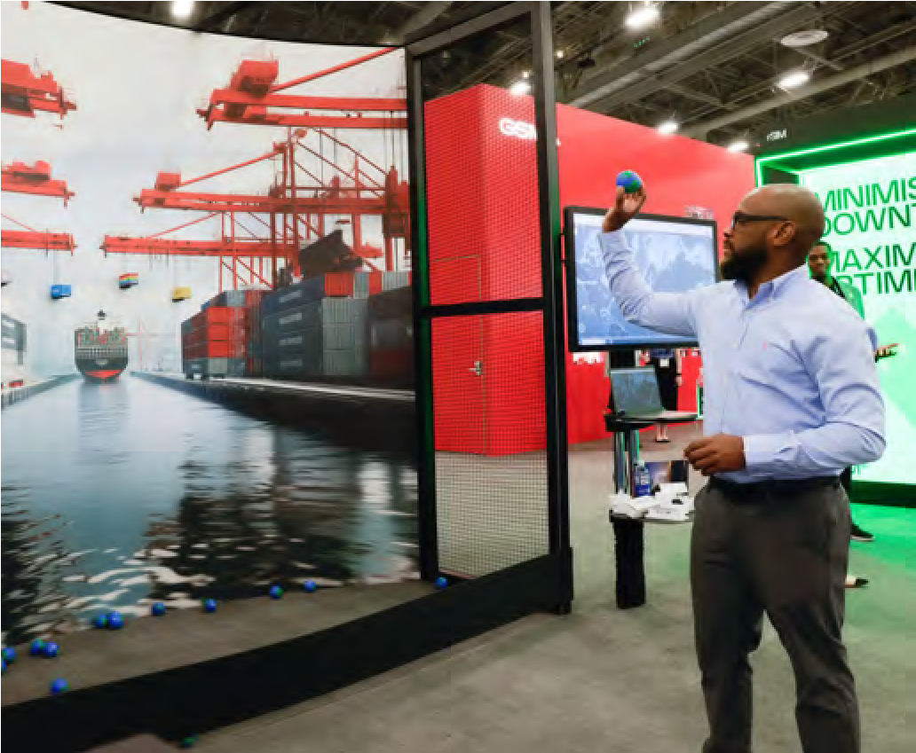

BeWhere’s Smart Logistics project showcased at MWC Las Vegas 2024

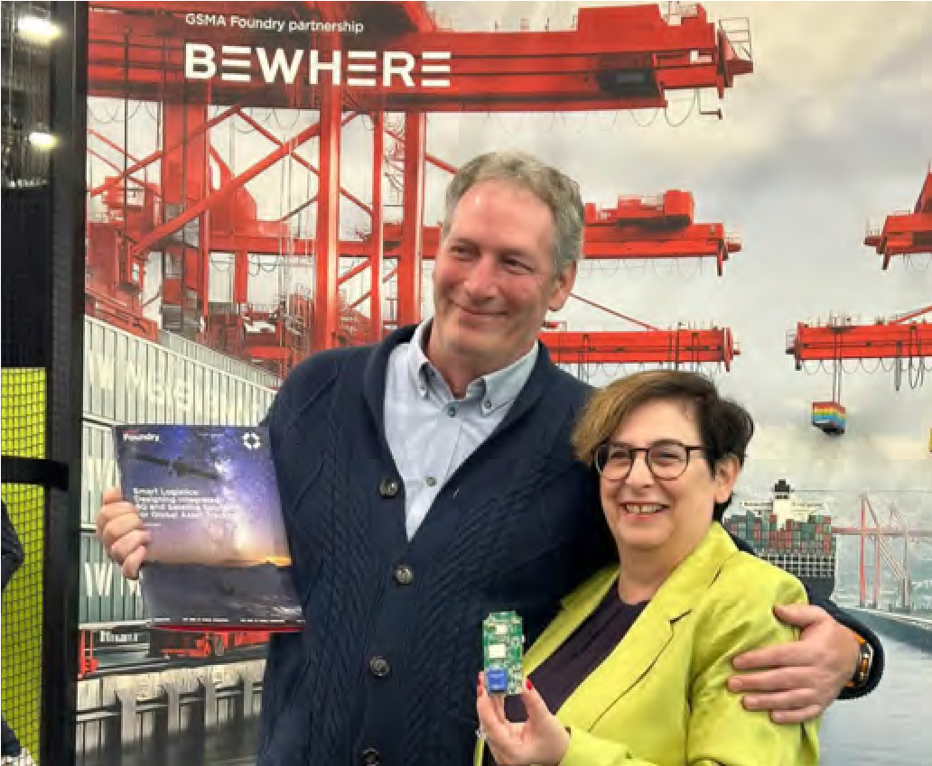

Owen Moore, CEO, BeWhere and Barbara Pareglio, Senior Technical Director, GSMA, promoting the Smart Logistics:

Global Assets Tracking Whitepaper at MWC Las Vegas 2024

Partners: BeWhere

**Ports Efficiency and Safety – the role of 5G networks**

### and UAVs

Smart Mobility

The GSMA Foundry worked with Unmanned Life to explore the potential to transform port operations with the use of 5G-augmented autonomous drone technology supported by the GSMA’s Open Gateway APIs.

This project addresses how ports can leverage private 5G networks and UAVs (uncrewed aerial vehicles) to enhance their operational capabilities, enabling real-time monitoring and improved decision-making in a complex port environment.

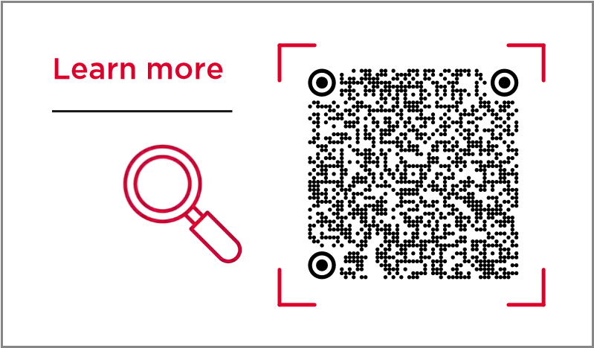Unmanned Life demo on the GSMA Pavilion at MWC

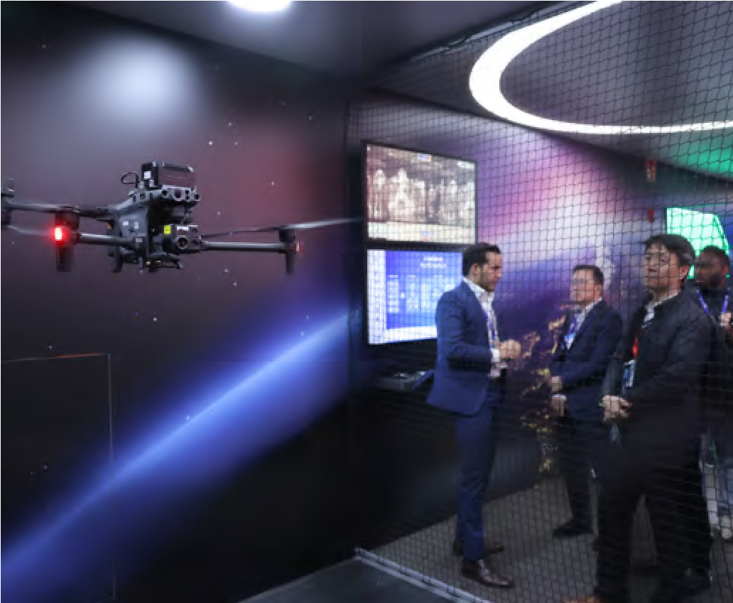

Barcelona 2024

Partners: Unmanned Life

### 5G-Advanced Intelligent Packet Core – delivering differentiated experiences (GSMA Foundry

Excellence Award Winner)

5G Monetisation

As 5G coverage expands globally, more and more mobile operators have shifted their focus from accelerating user migration to 5G monetisation. However, the wide adoption of traditional traffic-based operation models leads to homogeneity of services, while a traditional network architecture cannot keep up with the diversity of user service requirements.



In this Foundry project, Huawei, AIS, China Mobile, e&, Globe, STC, Sunrise and Zain KSA are developing the concept of experience monetisation, supported by the convergence of networks and intelligence. Based on the intelligent capabilities of the NWDAF (network data analytics function), an intelligent packet core can enable mobile operators to provide personalised and differentiated experiences. As well as improving the user experience, this approach opens up new opportunities for operators to increase their revenue.

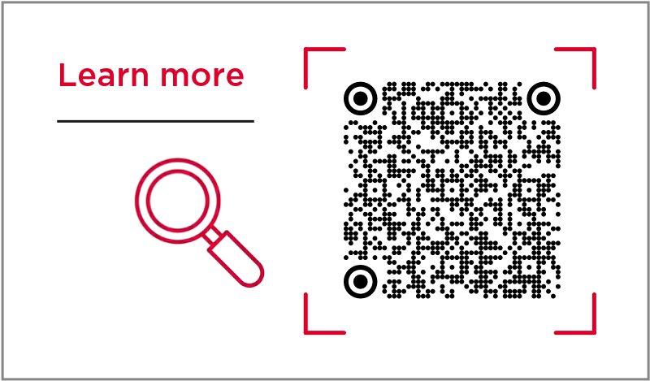

Partners: AIS, China Mobile, Huawei

### IoT Connectivity – from above the skies

Non-Terrestrial Networks

The Foundry is working with Skylo, Sony Semicon (IL) and Murata to harness a combination of cellular and satellite connectivity to propel the expansion of the Internet of Things (IoT). Sony’s ALT1250 chipset, compliant with 3GPP

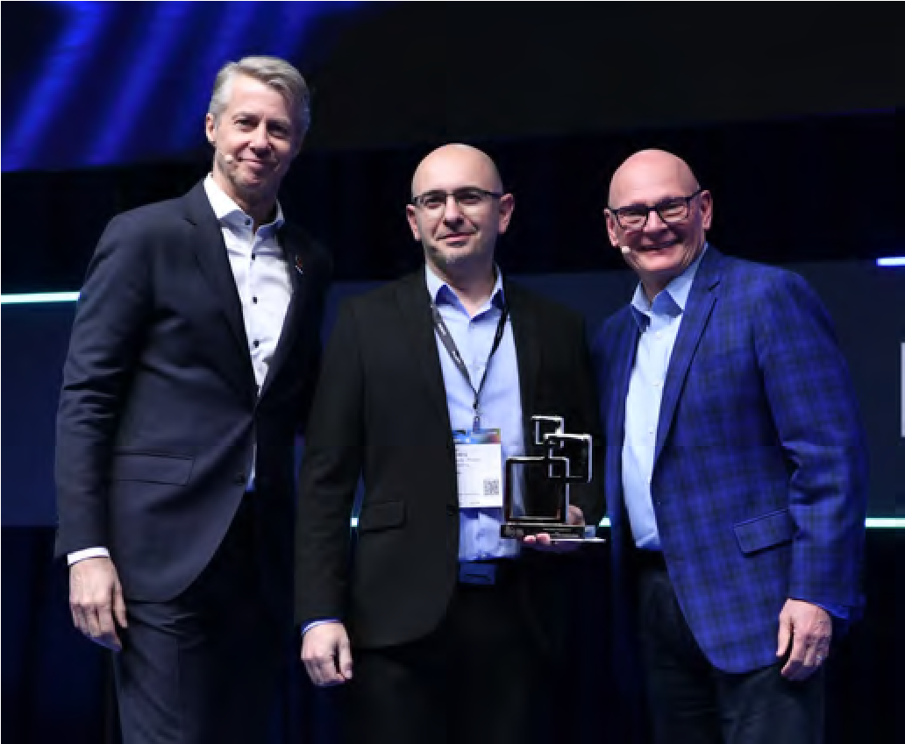

Release 17 NTN, seamlessly supports LTE-M, NB-IoT and 2G connectivity, enabling global coverage through over-the-air software upgrades, without the need for hardware changes. Using the

chipset, Murata’s 1SC module provides combined LTE M/NB-IoT terrestrial and non-terrestrial connectivity for diverse IoT devices.

Skylo’s non-terrestrial network (NTN) connectivity, facilitated by the ALT1250 chipset, paves the way for a myriad of IoT applications in rural areas and facilitates real-time tracking, eliminating coverage gaps. This innovative amalgamation of cellular and NTN on the same chipset promises to substantially reduce the total cost of ownership for NTN solutions.

Sony Semicon (IL) winning the GSMA Foundry Innovation GLOMO Award in Barcelona 2024

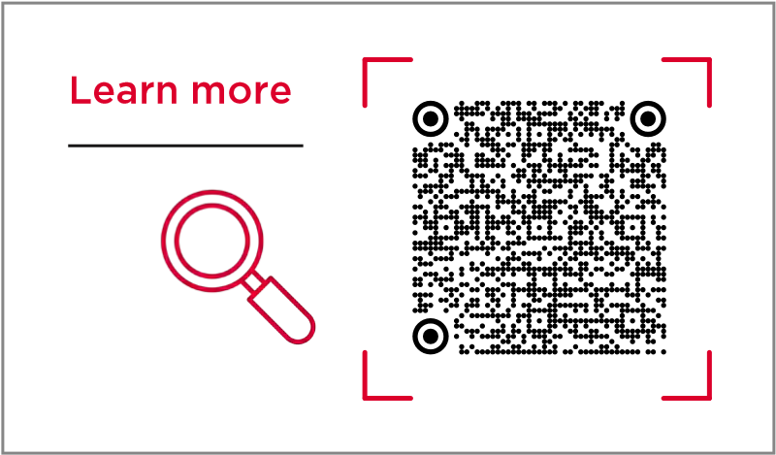

Partners: Skylo, Sony Semiconductor Israel (Sony) and Murata

**API Solutions – authentication, fraud prevention and new**

### customer experiences

Application Programming Interfaces (APIs)

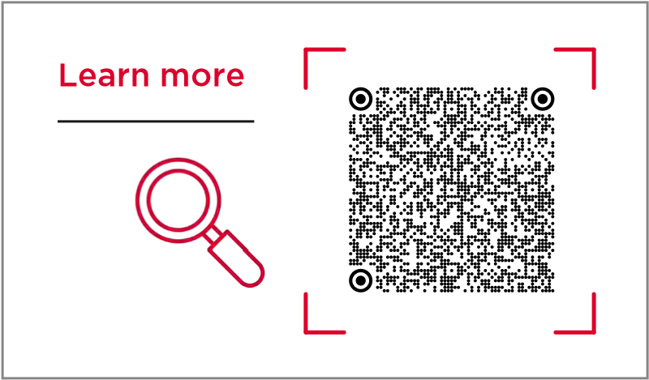Led by Telkomsel of Indonesia, this project focuses on delivering fraud prevention, digital identity authentication and enhanced customer experiences through innovative solutions such as Telco Verify, a secure network-based authentication system. More than 15% of the Indonesian population has adopted QRIS -based payments, underlining the growing reliance on mobile-driven financial services. Mobile operators’ APIs can secure these transactions by linking mobile numbers with personal identities, mitigating risks from fraud and malware.

With the support of the Foundry, Telkomsel has enabled the integration of API services, such as SIM Swap and Number Verification, across multiple industries, including financial services and government platforms. The APIs have reduced the risk of identity fraud in digital banking and e-commerce transactions, a critical issue in Indonesia’s digital banking market.

Partners: Telkomsel

|  |
| --- |
| **New Multimedia Communications - for the 5G era** |

5G Monetisation

Supported by the Foundry, China Mobile is further developing its pioneering Video Ring Back Tone (VRBT) service, enabling callers to view a short video on their handset before the call is answered. Commercialised by China Mobile in 2018, VRBT has since rapidly gained popularity, reaching over 400 million users by March 2024. This success translates into significant commercial impact, with VRBT generating over US$1.5 billion in revenue in 2023 alone.

VRBT products are now used by nearly 50% of China Mobile’s total subscriber base, demonstrating considerable market penetration and user engagement.

The versatility of VRBT goes beyond personal use to support enterprise applications, including corporate publicity and media communications, showcasing the solution’s broad utility across both consumer and business markets. As a key contributor to industry standards, China Mobile has built a strong foundation in VRBT technology and intellectual property rights, positioning the company as a market leader in VRBT product development and commercialisation. The operator says it owns more than 70% of global VRBT patents.

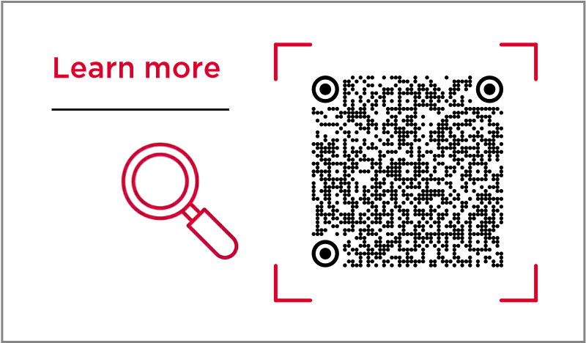

**Video Ring Back Tone**

¥



VRBT

**400m**Users

by **March 2024**

## VRBT1.5



$

**generatingBn**

**over**

**Of China Mobile’s subscribers 50%** base

**2023**

in

of subsciber are using **VRBT**

Partners: China Mobile

|  |
| --- |
| **Expanding the Internet of Things – everywhere**  (GSMA Foundry Excellence Award Winner) |

IoT, Non-Terrestrial Networks

Sateliot is pioneering cost-effective IoT connectivity via satellites to provide coverage for the 80% of Earth’s surface not served by terrestrial networks. For many IoT applications, such as infrastructure monitoring and environmental sensors, traditional satellite solutions are too expensive and power hungry. But new 3GPP standards (Releases 17 and 18) specify the delivery of low-cost, low-power NB-IoT via non-terrestrial networks (NTN). Using a “store and forward” method with low-earth orbit (LEO) satellites, Sateliot supports data transfer with delays of about 45 minutes, conserving device battery life and reducing costs. Starting with four satellites in 2025, the company plans to scale to over 100 by 2028, improving service from two daily messages per device to near real-time updates.

Sateliot, which has secured €250 million in contracts and €40 million in strategic funding, is targeting the agriculture, infrastructure and automotive sectors. Its NB-IoT modules, priced at US$5–US$10, are designed to support large scale applications, such as livestock monitoring. Sateliot is aiming for €500 million revenue by 2027 and €1 billion by 2030. Supported by the GSMA Foundry, it has built partnerships with mobile operators to ensure seamless roaming and has secured advanced chipsets from Qualcomm to accelerate adoption of satellite IoT.

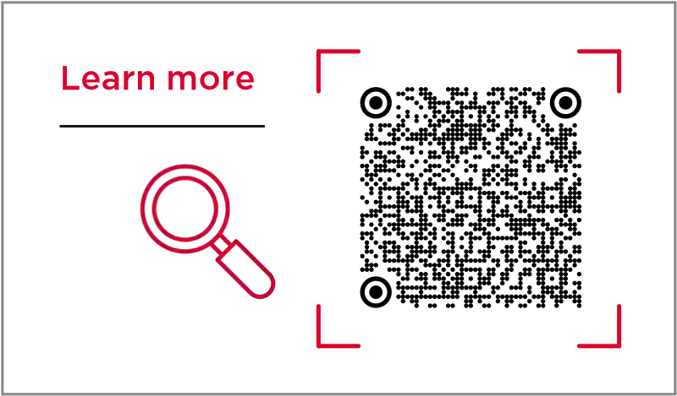

### Revenue aims



€

€

€

Supported by GSMA Foundry

by by

**500m 2027** +€ **1Bn 2030**

Partners: Sateliot

#### Addressing the AI Language Gap



(GSMA Foundry Excellence Award Winner)

Artificial Intelligence

VEON’s Beeline Kazakhstan and its software company QazCode, in collaboration with the Government of Kazakhstan and Nazarbayev University, have developed an open-source Kazakh-language large language model (Kaz-LLM). This project accelerates the adoption of AI-powered products while addressing the the global challenge on the AI language gap for low-resource languages . With over 150 billion tokens collected, curated, synthesized, and translated, the Kaz-LLM interacts seamlessly in Kazakh, Turkish, English, and Russian. The project received technical support from Foundry strategic partners Barcelona

Supercomputing Center.

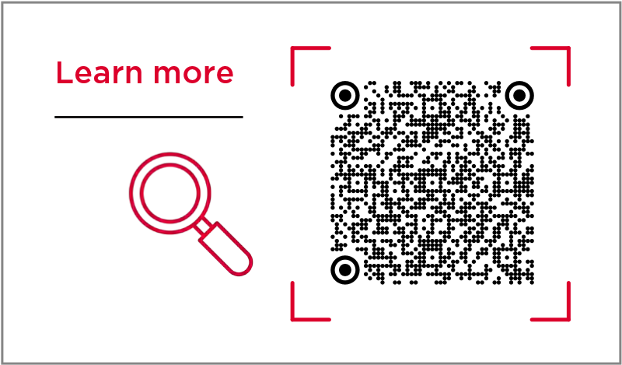

Partners: Veon, Barcelona Supercomputing Center, Beeline Kazakhstan, Qazcode

#### Delivering Robust Connectivity - at major events

|  |
| --- |
| Our collaboration with the GSMA  Foundry has been invaluable to CloudRAN.AI. Specifically, it has enabled us to accelerate the development and deployment of our innovative HyperCell solution. The Foundry’s global network was instrumental in helping us secure key partnerships. For example, by leveraging the brand influence and endorsement of GSMA Foundry, we were able to pilot our solution with the partner more quickly.  We believe the collective impact of our work, facilitated by the GSMA Foundry, has been significant. Together, we’ve contributed to advancing the adoption of private 5G and private to public RAN sharing. Our project has the potential to improve connectivity both in vertical sectors and public MNO service.  We are incredibly proud of what we’ve accomplished together and look forward to continuing this successful partnership in the future.  **Lion Li -** Co-founder, CloudRAN.AI. |

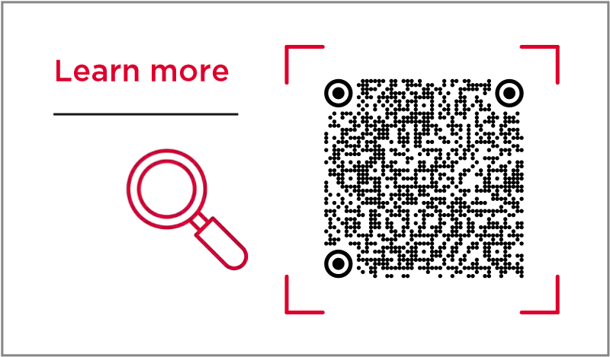(GSMA Foundry Excellence Award Winner) CloudRAN.AI has developed an “

Network Efficiency, Optimisation

innovative 5G hyper-cell solution to address connectivity challenges at large-scale events. The solution merges coverage from multiple base stations into a single hyper-cell using centralised and distributed units managed via a standardised interface. This architecture eliminates latency issues and dropped connections, common in traditional setups. The network can also integrate with public cellular systems to alleviate congestion during events, enhancing the experience for spectators.

During a 2024 pilot at the Autódromo Velocitta in

Brazil, a private 5G network seamlessly transmitted HD video from eight high-speed race cars to broadcasters, providing immersive 360-degree perspectives for viewers. The network delivered 230Mbps average uplink capacity, enabling high-quality video uploads while maintaining cost efficiency. CloudRAN.AI’s cloud-native design allows quick and straightforward deployment, similar to setting up Wi-Fi. Following the pilot’s success, the company is working with the Foundry to commercialise the solution through partnerships with event organisers and mobile network operators. CloudRAN.AI believes the solution can address connectivity needs at various major events, including football matches, through resource-sharing models.

Partners: CloudRAN.AI

#### Airborne Base Stations – restoring connectivity

5G Coverage

ZTE has developed airborne base stations mounted on uncrewed aerial vehicles (UAVs) to rapidly restore connectivity during natural disasters. These stations can support both private emergency networks and public cellular coverage, ensuring communication for emergency services and affected individuals. They have been deployed in China in response to floods, typhoons, and earthquakes, showcasing their effectiveness in disaster-stricken areas by quickly re-establishing communication networks.



The system uses satellite and wireless technologies for backhaul and can provide coverage over large areas with minimal deployment time. With the support of the Foundry, ZTE plans to deliver this technology internationally, contingent on local regulations and spectrum availability.

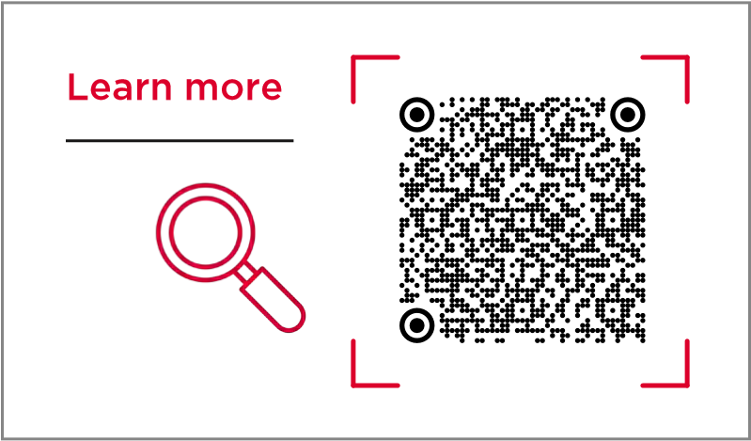

Partners: ZTE

#### Networks Operations - end-to-end automation

(GSMA Foundry Excellence Award Winner)

Artificial Intelligence, Network Efficiency, Optimisation

ZTE is employing artificial intelligence (AI) to automate and optimise network operations, addressing inefficiencies in traditional telecoms operations and maintenance processes. The solution employs cross-domain agents supported by advanced natural language models to improve integration, resource management and service quality.

Deployed by China Mobile at major events, ZTE’s AI agents have enhanced efficiency, traffic handling and fault resolution. Working with the GSMA Foundry, ZTE aims to expand this technology globally, driving productivity and adaptability in digital network ecosystems, with a focus on seamless operations and real-time responses.

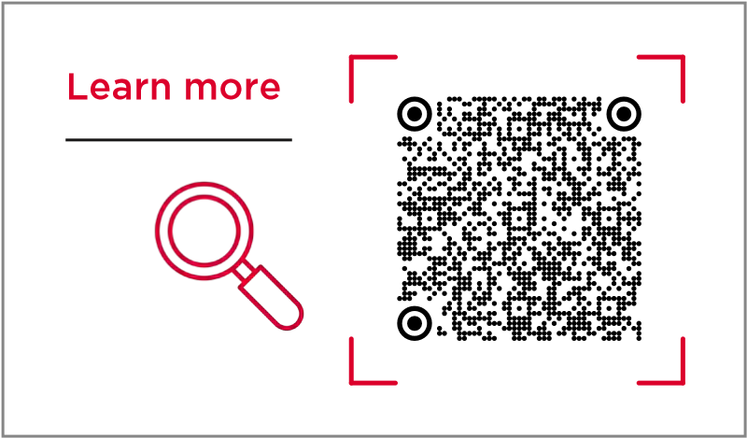

Partners: China Mobile, ZTE

#### Enriching Entertainment – with minimalist 5G-Advanced

5G-Advanced, Network Efficiency, Optimisation

ZTE has developed a minimalist 5G-Advanced network to enhance entertainment experiences, particularly in virtual reality (VR) and live broadcasting. This network eliminates the need for a traditional core network by using base station computing power, enabling cost-effective deployment.

It supports high throughput and low latency, facilitating seamless VR experiences without bulky equipment and flexible live broadcasting. The technology has been applied in various settings, including VR theatres and major events, demonstrating improved scalability and performance.

Supported by the GSMA Foundry, ZTE is expanding this solution globally, anticipating increased demand driven by advancements in high-resolution video and immersive content.

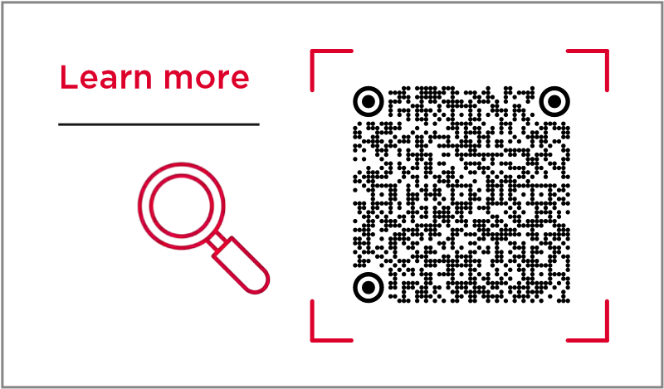

Partners: ZTE



GSMA Connected

Communities

**ONNECTED COMMUNITIES GSMA CONNECTED COMMUNITIES GSMA CONNECTED COMMUNITIES GSMA CONNECTED COMMUNITIES GSMA CONNECTED C**

**MOBILE INNOVATION REPORT 2025**

**07.** GSMA CONNECTED

### COMMUNITIES

Supported by the Foundry, GSMA Connected Communities organise industry-focused forums that unite members and key stakeholders to address shared goals and challenges across specific sectors.

By fostering collaboration and facilitating innovative problem-solving, these communities provide a robust network to forge transformative partnerships and accelerate innovation pipelines.

#### Manufacturing and Production

The GSMA Manufacturing and Production Community drives industrial transformation by uniting stakeholders to accelerate the adoption of 5G, AI and other digital technologies across manufacturing, mining, logistics and other sectors, fostering collaboration to develop and deploy safer, more efficient, and sustainable operations. By joining, members gain access to a unique network focused on taking the lead in key issues and driving Industry 4.0.

#### Fintech and Commerce

The mobile ecosystem is central to fintech and commerce. GSMA members and fintech partners collaborate to explore common interests, key issues, and share insights and case studies. They create new opportunities and drive innovative projects. The GSMA Connected Fintech and Commerce Community leads discussions, monitors fintech developments, and provides collaboration opportunities to build and deploy new solutions. This community prioritises supporting partners in exploring common interests, monitoring insights, and driving innovation.

#### Aviation

The GSMA Aviation Community collaborates on driving digital transformation in aviation, advancing automation, uncrewed aerial vehicles (UAVs), and electric vertical take-off and landing (eVTOL) craft, while prioritising safety and shaping the future of airspace regulations and technologies.

#### IoT

The GSMA IoT Community accelerates IoT growth through industry collaboration, optimised networks, and key enablers, offering resources, news and updates on global events shaping the connected future.

#### Identity and Data

The Identity and Data Community enables collaboration across the ecosystem, sharing best practices and driving mobile-led identity solutions to support digital transformation and unlock new business opportunities.

#### NTN and Satellite

The Non-Terrestrial Networks (NTN) Community unites mobile and satellite technologies, driving collaboration through the GSMA Foundry to integrate satellite communications with 5G and future 6G networks for real-world innovation.

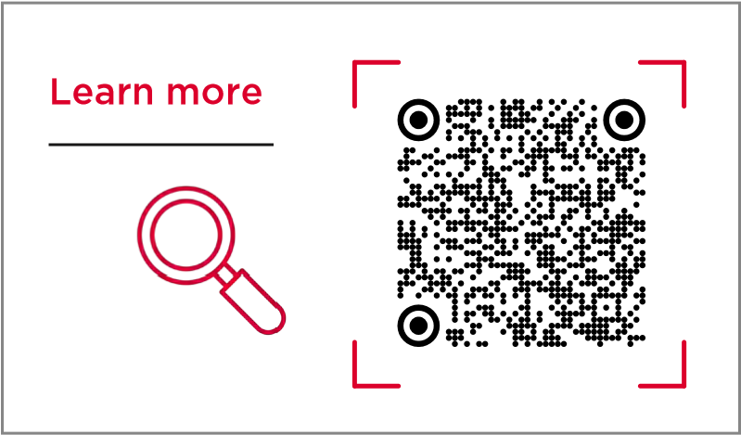



Get

Involved

**VOLVED GET INVOLVED GET INVOLVED GET INVOLVED GET INVOLVED GET INVOLVED GET INVOLVED GET INVOLVED**

**MOBILE INNOVATION REPORT 2025**

### 08. GET INVOLVED

Be part of shaping the future of mobile technology - reach out to explore how you can get involved with GSMA Foundry.

Contact us:

foundry@gsma.com www.gsma.com/Foundry



Richard Cockle

Head of GSMA Foundry and

Connected Industries



Ioanna Nikolaou

Marketing and Communications



Andrew Bell



Faisal Zia



Nicola Gordon

Director, Business Marketing Director, Technical Director,

Programme Delivery



Development & Partnerships

Emma Henderson



Technology

Akhil Vijay



Jessica Bukenya

Marketing and Project Management Project Management

Communications

**1.**

**www.gsma.com/foundry**

**MOBILE INNOVATION REPORT 2025**

#### GSMA HEAD OFFICE

1 Angel Lane

London

EC4R 3AB

UK

Email: info@gsma.com